Helping a person with dementia to eat well
Information Leaflet

This leaflet aims to help relatives and carers support people with advancing dementia with good nutrition.

Eating and mealtimes are an important time for us all, and a valuable time to spend with a person with dementia. People with dementia want to eat independently for as long as possible, and this should be encouraged. In the more advanced stages of dementia eating and drinking can bring challenges; they may forget to eat, forget they have eaten or be easily distracted from eating.

There are many practical things that can help us to enjoy food and find mealtimes a relaxing and enjoyable time. At advanced stages, it is often necessary to help the person with dementia to eat and drink. The guidance in this leaflet can make a huge difference to their ability to enjoy their food whilst maintaining as good a nutritional status as possible.

In very advanced stages of dementia weight loss is to be expected and swallow can be affected. Carers may need to access the support and advice of professionals such as a GP, speech and language therapist and/ or a dietician.

Ten Top Tips

1. Practical Help
Appetite can be stimulated before meals by speaking to the person with dementia about their next meal, being enthusiastic and encouraging their interest in food, tempting them with foods that they like.

People feel more like eating if they are clean, comfortable and relaxed before each meal arrives. Offer the opportunity to wash their hands, put on glasses, or have hearing aids/dentures in place.

Food can be cut into smaller pieces, bread buttered and fruit peeled where appropriate. Removing wrappers and lids may also help. Plates and bowls which have higher sides to prevent spillage can be useful, and non-slip mats can be used to stop crockery slipping.

Cups can be different shapes, with one or two handles, and different weights. Sometimes it is easier to use a transparent cup when helping a person to drink.

If the person has swallowing difficulties, straws and feeder cups should only be used if this was part of recommendations following a swallow assessment.

2. Communication & Observation
Eye contact and appropriate touch may help to gain the person’s attention. You can check they are alert and understand it is meal time.

It is helpful to observe the person for signs of discomfort or distress when eating. Prompting the person gently to chew and swallow the food may be necessary and watch the swallow after each mouthful before giving another spoonful.

3. Position & Environment
Patients positioned comfortably in an upright position will find it easier to swallow and digest the food.

Where a tray or table is being used, the position should be adjusted to make sure the person is comfortable
.
It is helpful to sit facing the person, at the same level as them so that they can see you and the food.

Reducing background noise and clutter can be helpful at mealtimes. Make sure any unpleasant sights, smells or distracting sounds are minimised.

4. Take Time
It is best to be as unhurried as possible. Offer small amounts at a time and pause between each mouthful. Don’t have a loaded spoon waiting, as this can look as if you are saying ‘hurry up’.

5. Drinks & Digestion
Find out if the person prefers to drink with or after the meal. Alternating a little drink then food, drink then food may help digestion.

Food can be mixed with gravy or sauces to make it easier to chew or swallow if the person likes this. Serving a smaller portion may be more tempting as large portions can overwhelm.

6. The Food
You can tell the person about the food and let them see their food on the plate or dish as you feed them.

Letting them smell the food if they want to may encourage them to eat. Think about the temperature of the food/drink you are providing and consider how the food is presented.

Near the end of the meal you can let them know how much you have left.

7. Looking After Yourself Whilst Helping Others
If you are helping someone to eat and drink it is good to make sure you are seated or remain in a comfortable position for your back, try to avoid twisting and bending.

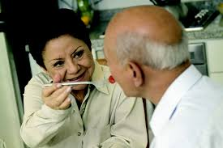

8. Food Fortification
High calorie food and drinks can be encouraged where the person is losing weight or not eating well. Fortifying food simply means adding extra nutrients to food without increasing the amount that needs to be eaten. One of the best fortifiers is dried milk powder and this is a good source of protein, energy and some micronutrients. It can be added to milk for cereal and drinks, custard, porridge, yoghurt, milk puddings, cream soups and mashed potato.

9. Involving Speech and Language, and Dieticians
If you notice a problem with feeding, significant unexplained weight loss, swallowing, coughing when eating, choking or gagging, it is important to let the person’s GP know. The GP will be able to give advice and may refer the person on to a dietician or speech and language therapist.

10. Mouth Care
Keeping the mouth clean and moist is an important part of daily routine. Check if dentures fit well and are comfortable. You can also check the tongue, gums and teeth for any signs of oral thrush (milky white deposit). If this is present it should be reported to a doctor as soon as possible.

This guide was developed by staff from Stockport NHS Foundation Trust: Stockport Palliative Care Team Facilitators, with assistance from J.Parsons, A.Hewitt (Dieticians) and J.Kindell (SALT). Acknowledgment goes to the Peterborough Palliative care in Dementia Group, their key work informed these local guidelines.

If you would like this leaflet in a different format, for example, in large print, or on audiotape, or for people with learning disabilities, please contact:
Patient and Customer Services, Poplar Suite, Stepping Hill Hospital. Tel: 0161 419 5678 Information Leaflet. Email: PCS@stockport.nhs.uk.

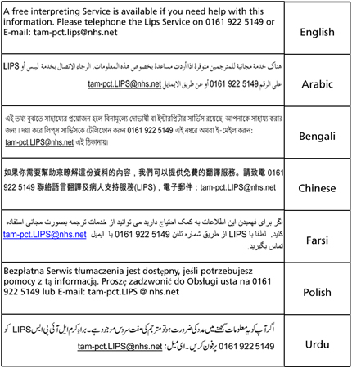

Our smoke free policy
Smoking is not allowed anywhere on our sites. Please read our leaflet 'Policy on Smoke Free NHS Premises' to find out more.

Leaflet number | MED88
Publication date | December 2013
Review date | December 2016
Department | Integrated Care, Palliative Care
Location | Stepping Hill Hospital

