AUDIT tool to look at increasing the use of Nitrofurantoin versus Trimethoprim and 3-day courses of antibiotics for uncomplicated urinary tract infections (UTIs)

Aim: The aim of this audit is to evaluate adherence to national and local guidelines of prescribing of both trimethoprim and nitrofurantoin for treatment of lower UTIs in both men and women.
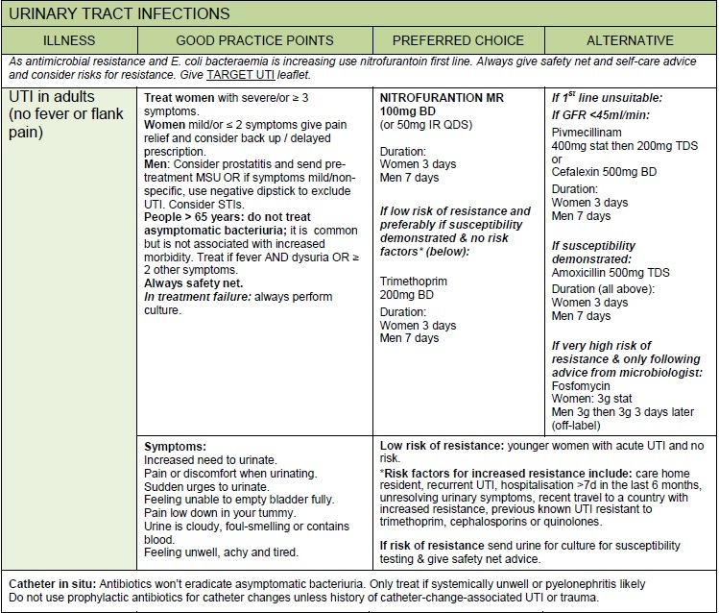
According to PHE guidance, a 3-day course of antibiotics is sufficient for acute symptomatic UTI in most women with no fever or flank pain who are not pregnant. The ESPAUR report (2016) found that there is wide variation in the rates of resistance to trimethoprim with resistance ranges from 16.3% to 66.7% across CCGs. This may be related to variation in sending urine samples for laboratory testing, however, the report states that 86% of CCGs have resistance rates greater than 25%, highlighting that trimethoprim can no longer be advised as the first-line empiric antibiotic treatment for UTIs in England. Nitrofurantoin is recommended first-line in our current antimicrobial guidance for acute simple UTIs, and in women 3 days of antibiotics should be prescribed:
Method: Run 2 separate searches and then complete the data collection sheet. At least 20 patients should be audited for each drug, but use your judgement based on list size and findings.
Search 1: All patients prescribed Trimethoprim 200mg tablets in the last month
Search 2: All patients prescribed Nitrofurantoin (all types) in the last month
Medicines optimisation technicians or MCs can be used to run the searches and collect the data for the first 7 or 8 columns at the discretion of the meds optimisation pharmacist. Use the ‘other’ column’ to records additional relevant information such as care home resident or pregnant or dipstick checked. The ‘comments’ column should be used to record findings such as incorrect course length or duration of treatment or mark as unclear if you are unable to decide based on what is documented in the patients record if the course is appropriate.
Please note:
- Choice may be affected by the patients eGFR
- Recurrent UTI is generally defined as >3 UTIs in 12 months

Recommended reading
More detailed information and evidence relating to the diagnosis and treatment of UTIs can be found at: cks.nice.org UTIs

Results
Present the results of the audit to your practice GPs and prescribing clinicians along with any recommendations such as increasing the use of nitrofurantoin first line and 3 day prescribing.
The TARGET Antibiotics Toolkit provides guidance and other support to clinicians to improve responsible antimicrobial prescribing in primary care. The Toolkit now contains patient leaflets and information on UTIs, and can be accessed at: www.rcgp.org.uk/targetantibiotics
A copy of the self-care ‘Treating Your Infection – Urinary Tract Infection (UTI)’ leaflet can be found at the end of this document. It is not yet available on EMIS web templates, but it could be saved to a folder or on desktops to access during consultations or copies printed off to give out by hand.
The quick reference guide for primary care can be used for discussions around diagnosis and treatment of UTIs and where a delayed Rx with advice may be considered appropriate (see below)

Diagnosis of UTI

Quick Reference Guide for Primary Care

URINARY SYMPTOMS IN ADULT WOMEN <65 DO NOT CULTURE ROUTINELY
In sexually active young men and women with urinary symptoms consider Chlamydia trachomatis
AND
NO vaginal discharge or irritation
90% culture positive
Give empirical antibiotic treatment
Severe or ≥ 3 symptoms of UTI

- Dysuria
- Frequency
- Suprapubic tenderness

- Urgency
- Polyuria
- Haematuria

Laboratory microscopy for red cells is less sensitive than dipstick
UTI Unlikely
Negative nitrite, leucocytes and blood 76% NPV
or
Negative nitrite and leucocyte
Positive blood or protein

Consider other diagnosis

Reassure and give advice on management of symptoms
Positive nitrite, leucocytes and blood 92% PPV
or
positive nitrite alone
Review time of specimen
(morning is most reliable)
Treat if severe symptoms or consider delayed antibiotic prescription and
send urine for culture
URINE CLOUDY
Perform urine dipstick test with nitrite
When reading test WAIT for the time recommended by the manufacturer

Treat with first line agents on local or PHE Guidance

Negative nitrite

Positive leucocyte

UTI or other diagnosis equally likely

Probable UTI
Mild or ≤ 2 symptoms of UTI
(as above)
Obtain urine specimen
Urine NOT cloudy 97% NPV
Consider other diagnosis

UTI audit data collection sheet Date collected:
Patient ID | Gender and age | Name of drug and strength | Duration of treatment | No. of UTIs in last 12 months | Catheter in situ  Y/N | MSU sent  Y/N | Other relevant info * | Formulary choice followed?  Y/N* | Appropriate course length Y/N* | Comments*

*These columns to be completed by the reviewer

For women outside care homes with suspected uncomplicated urinary tract infections (UTIs) or uncomplicated recurrent UTIs
Treating Your Infection – Urinary Tract Infection (UTI)

Possible urinary symptoms | The outcome Recommended care | Types of urinary tract infection (UTI)
Mild, or 1 to 2, symptoms or vaginal discharge (or both)  • Antibiotics less likely to help.  • Usually lasts 5 to 7 days.  Self-care and pain relief. Symptoms are likely to get better on their own.  Antibiotic prescription  • Immediate treatment with antibiotics, plus self-care.  Delayed or backup prescription. Start antibiotics if symptoms:  • get worse  • do not get a little better with self-care after 24 to 48 hours.  Severe, or 3 or more, symptoms and no vaginal discharge  Antibiotics are likely to help, symptoms  • should start to improve within 48 hours  • usually last 3 days.  Frequency: Passing urine (wee) more often than usual  Dysuria: Burning pain when passing urine  Urgency: Feeling the need to pass urine immediately  Haematuria: Blood in your urine  Nocturia: Needing to pass urine in the night  Suprapubic pain: Pain in your lower tummy  Other things to consider  Recent sexual history  • Some sexually transmitted infections (STIs) can have symptoms similar to those of a UTI.  • Inflammation due to sexual activity can feel  similar to the symptoms of a UTI. |  | 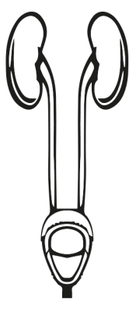  UTIs are caused by bacteria getting into your urethra or bladder, usually from your gut. Infections may occur in different parts of the urinary tract.  Bladder (stores urine)  Infection in the lower urinary tract  • Cystitis (sis-tight-is)  Kidneys (make urine)  Infection in the upper urinary tract  • Pyelonephritis (pie-lo-nef-right-is)  Urethra (takes urine out of the body)  Infection or inflammation in the urethra  • Urethritis (your-ith-right-is)  Urethra (takes urine out of the body)  Infection or inflammation in the urethra  • Urethritis (your-ith-right-is)  Kidneys (make urine)  Infection in the upper urinary tract  • Pyelonephritis (pie-lo-nef-right-is)  Bladder (stores urine)  Infection in the lower urinary tract  • Cystitis (sis-tight-is)  UTIs are caused by bacteria getting into your urethra or bladder, usually from your gut. Infections may occur in different parts of the urinary tract.  Kidneys (make urine)  Infection in the upper urinary tract  • Pyelonephritis (pie-lo-nef-right-is)  Bladder (stores urine)  Infection in the lower urinary tract  • Cystitis (sis-tight-is)  UTIs are caused by bacteria getting into your urethra or bladder, usually from your gut. Infections may occur in different parts of the urinary tract.  Urethra (takes urine out of the body)  Infection or inflammation in the urethra  • Urethritis (your-ith-right-is)  Kidneys (make urine)  Infection in the upper urinary tract  • Pyelonephritis (pie-lo-nef-right-is)  Bladder (stores urine)  Infection in the lower urinary tract  • Cystitis (sis-tight-is)  UTIs are caused by bacteria getting into your urethra or bladder, usually from your gut. Infections may occur in different parts of the urinary tract.  Urethra (takes urine out of the body)  Infection or inflammation in the urethra  • Urethritis (your-ith-right-is)  Kidneys (make urine)  Infection in the upper urinary tract  • Pyelonephritis (pie-lo-nef-right-is)  Bladder (stores urine)  Infection in the lower urinary tract  • Cystitis (sis-tight-is)  UTIs are caused by bacteria getting into your urethra or bladder, usually from your gut. Infections may occur in different parts of the urinary tract.  Urethra (takes urine out of the body)  Infection or inflammation in the urethra  • Urethritis (your-ith-right-is)  Kidneys (make urine)  Infection in the upper urinary tract  • Pyelonephritis (pie-lo-nef-right-is)  Bladder (stores urine)  Infection in the lower urinary tract  • Cystitis (sis-tight-is)  UTIs are caused by bacteria getting into your urethra or bladder, usually from your gut. Infections may occur in different parts of the urinary tract.  Urethra (takes urine out of the body)  Infection or inflammation in the urethra  • Urethritis (your-ith-right-is)

Self-care to help yourself get better more quickly | When should you get help?  Contact your GP practice or contact NHS 111 (England), NHS 24 (Scotland dial 111), NHS direct (Wales dial 0845 4647) or GP practice (N.Ireland) | Options to help prevent a UTI | Antibiotic resistance
Leaflet endorsed by:  Leaflet developed in collaboration with these professional societies.  Leaflet developed in collaboration with these professional societies. Leaflet developed in collaboration with these professional societies.  • Drink enough fluids to stop you feeling thirsty. Aim to drink 6 to 8 glasses including water, decaffeinated and sugar-free drinks.  • Take paracetamol or ibuprofen at regular intervals for pain relief, if you’ve had no previous side effects.  • You could try taking cranberry capsules or cystitis sachets.  These are effective for some women. There is currently little evidence to support their use.  • Consider the risk factors in the ‘Options to help prevent UTI’ column to reduce future UTIs. | The following symptoms are possible signs of serious infection and should be assessed urgently.  Phone for advice if you are not sure how urgent the symptoms are.  1. You have shivering, chills and muscle pain.  2. You feel confused, or are very drowsy.  3. You have not passed urine all day.  4. You are vomiting.  5. You see blood in your urine.  6. Your temperature is above 38◦C or less than 36◦C.  7. You have kidney pain in your back just under the ribs.  8. Your symptoms get worse.  9. Your symptoms are not starting to  improve a little within 48 hours of taking  antibiotics.  • Drink enough fluids to stop you feeling thirsty. Aim to drink 6 to 8 glasses including water, decaffeinated and sugar-free drinks.  • Take paracetamol or ibuprofen at regular intervals for pain relief, if you’ve had no previous side effects.  • You could try taking cranberry capsules or cystitis sachets.  These are effective for some women. There is currently little evidence to support their use.  • Consider the risk factors in the ‘Options to help prevent UTI’ column to reduce future UTIs. | It may help you to consider these risk factors.  Stop the spread of bacteria from your gut into your bladder. Wipe from front (vagina) to back (bottom) when you go to the toilet.  Avoid waiting to pass urine. Pass urine as soon as you need a wee.  Go for a wee after having sex to flush out any bacteria that may be near the opening to the urethra.  Wash the external vagina area with water before and after sex to wash away any bacteria that may be near the opening to the urethra.  Drink enough fluids to make sure you wee regularly throughout the day, especially during hot weather.  If you have a recurrent UTI, also consider the following.  Cranberry products: Some women find these effective, but there is currently little evidence to support this.  After the menopause: You could consider topical hormonal treatment, for example, vaginal creams.  Kidneys (make urine)  Infection in the upper urinary tract  • Pyelonephritis (pie-lo-nef-right-is)  Bladder (stores urine)  Infection in the lower urinary tract  • Cystitis (sis-tight-is)  UTIs are caused by bacteria getting into your urethra or bladder, usually from your gut. Infections may occur in different parts of the urinary tract. | Common side effects to taking antibiotics include thrush, rashes, vomiting and diarrhoea.  Antibiotics may not always be needed, only take them after advice from a health  professional. This way they are more likely to work if you have a UTI in the future.  Antibiotics taken by mouth, for any reason, affect our gut bacteria. These bacteria become resistant to antibiotics we take.  Antibiotic resistance means that the antibiotics cannot kill that bacteria.  The gut bacteria that cause UTIs are twice as likely to be resistant to antibiotics for at least 6 months after you have taken any antibiotic.  Kidneys (make urine)  Infection in the upper urinary tract  • Pyelonephritis (pie-lo-nef-right-is)  Bladder (stores urine)  Infection in the lower urinary tract  • Cystitis (sis-tight-is)  UTIs are caused by bacteria getting into your urethra or bladder, usually from your gut. Infections may occur in different parts of the urinary tract.
Version: 18
Published: Jan 2017
Revision: Jan 2020

