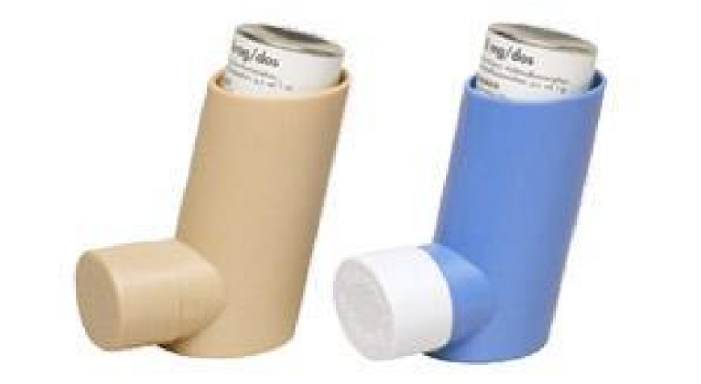

Metered Dose Inhaler (MDI)

If the inhaler has not been used before, a test dose should be fired into the air to prime the system.

- Remove cap.
- Shake well.
- Breathe out fully.
- Holding inhaler upright, bring chin up & place inhaler firmly between lips. Do not bite.
- Inhale slowly and deeply.
- Activate inhaler, while continuing to inhale. Continue to breathe in slowly for as long as comfortably possible.
- Hold breath for 10 seconds or as long as able.
- Remove inhaler from mouth.
- Breathe out slowly.
- For more than 1 puff, wait 30 seconds before repeating steps 2-9.
- Replace cap.
- If steroid – rinse mouth out after use.

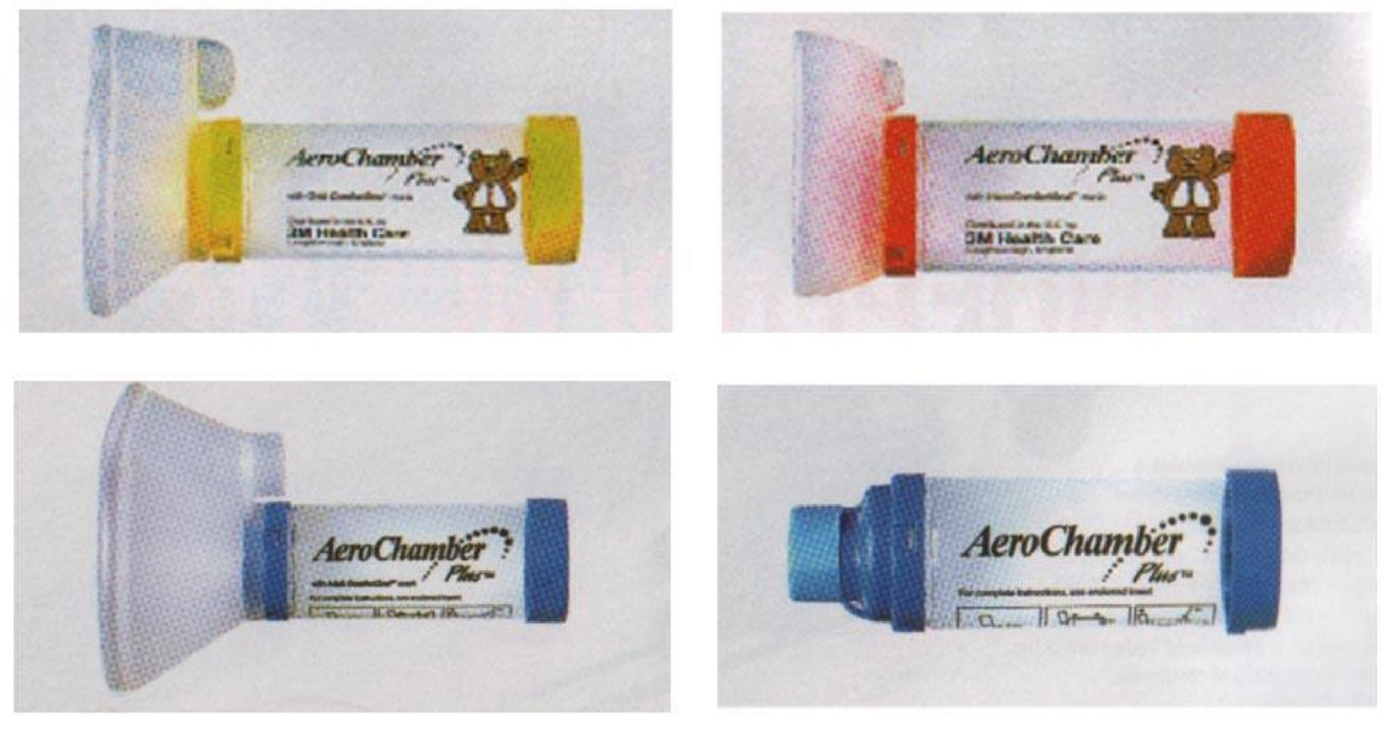

Spacer Device

- Remove caps from inhaler and spacer (if present).
- Shake inhaler and insert into back of spacer.
- Breathe out.
- Place spacer mouthpiece into mouth, ensure a good seal with lips.
- Press canister once.
- Take a deep slow breath in (aerochamber will make whistling sound if inhaling too quickly).
- Hold breath for 10 seconds, or as long as comfortable.
- Remove spacer and breathe out.
- If more than one dose is required, wait 30 secs before repeating.
- Tidal breathing can also be used.

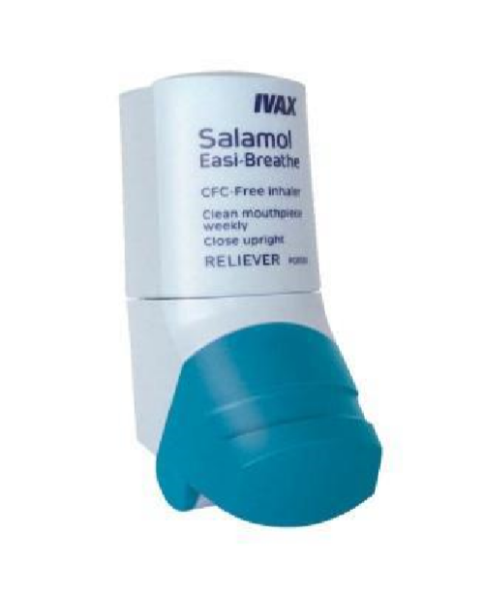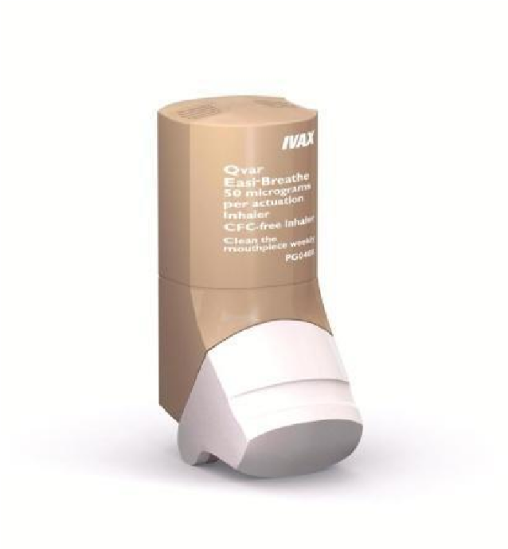

Easibreathe

- Shake inhaler well.
- Hold inhaler upright & open by folding down the cap.
- Breathe out fully.
- Holding inhaler upright, bring chin up & place inhaler firmly between lips. Do not bite. Do not block air vents.
- Breathe in slowly & deeply though the mouthpiece. Do not stop breathing in when the inhaler puffs the dose into your mouth.
- Hold breath for 10 seconds or as long as possible, then remove inhaler from mouth.
- Breathe out slowly.
- If you need to take a second dose, close the cap, wait 30 seconds, then repeat steps 1-7.
- Close cap for storage.

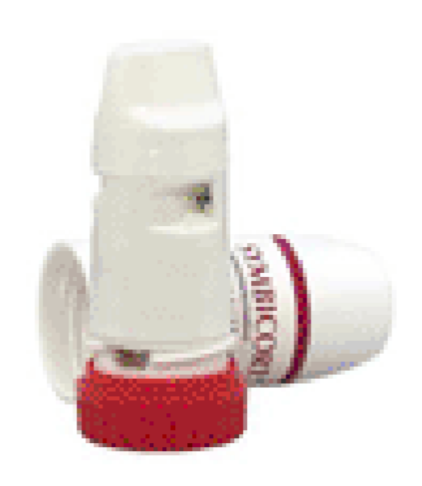

Turbohaler

Before use for the first time, turn the device twice

- Unscrew and lift off the cover
- Hold the turbohaler upright with the grip at the bottom
- Turn the grip fully in one direction and then back as far as possible (audible click).
- Breathe out away from the device.
- Place the mouthpiece between the lips and breathe in through the mouth as deeply and as hard as possible.
- Remove the turbohaler from mouth and hold breath for 10 seconds (or as long as comfortable).
- Breathe out slowly away from device.
- After 30 seconds, repeat steps 2-7 if more than one dose is required.
- Replace cover after use & rinse mouth out.

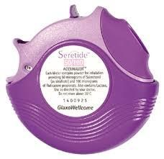

Accuhaler

- Open device by holding outer case with one hand and putting your thumb of the other hand of the grip.
- Rotate the outer case around the device as far as it will go. It will CLICK.
- Press the lever at the side down as far as it will go. It will CLICK (do not move up again).
- Hold the accuhaler level.
- Hold away from your mouth and breathe out gently.
- Put the device to lips and form a tight seal without biting.
- Breathe in quickly & deeply through the mouth.
- Remove accuhaler from mouth, shut mouth and hold breath for 10 seconds (or as long as comfortable).
- Breathe out slowly.
- Shut the accuhaler & the lever automatically returns to its original position.
- Usually only ONE dose. If a second dose is required, repeat steps 1-10.
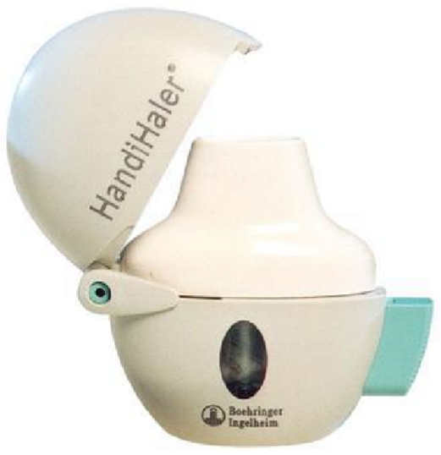

Handihaler

- Press and release piercing button to release dust cap.
- Open the dust cap by lifting upwards.
- Open the mouthpiece by lifting upwards.
- Remove capsule from blister and place in centre chamber.
- Close the mouthpiece (a click will be heard).
- Hold handihaler upright, press and release piercing button.
- Breathe out away from the inhaler.
- Raise handihaler to mouth and seal lips around mouthpiece.
- Breathe in deeply (should hear capsule rattle).
- Hold breath and take handihaler out of mouth.
- Repeat breathing in and out once more to completely empty capsule.
- Open mouthpiece and empty out used capsule.
- Close mouthpiece and dust cap for storage.
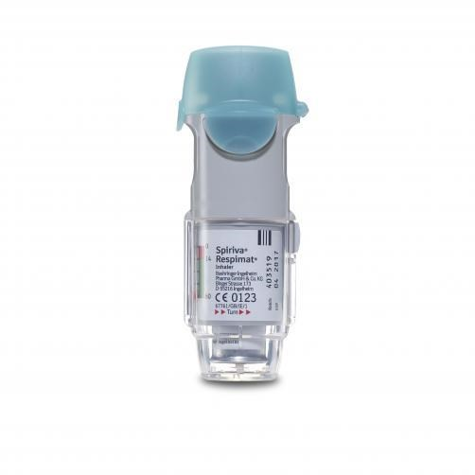

Respimat
See information sheet for how to load the inhaler for first use.
Within secondary care this step is performed by pharmacy.

- Hold upright with cap closed
- Turn the base in direction of red arrow half a turn until it clicks
- Open cap
- Breathe out. Close lips around mouthpiece without covering air vents
- Take a slow deep breath in, press dose release button and continue to breathe in
- Hold breath for as long as comfortable
- Close cap
- Repeat for second puff
- Close cap for storage

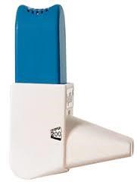
Easyhaler

- Remove dust cap

- Shake device 3 to 5 times, then hold upright

- Release dose by pressing device between thumb
  - and forefinger – just once. A click will be heard

  - (If you think you clicked more than once,
remove dose from mouthpiece by tapping it against palm of hand or, for example, a table and start again)

- To inhale dose, first breathe out normally, away a. from inhaler. Then put inhaler in mouth, seal
lips around mouthpiece and take a strong, deep breath

- Hold breath for 5 to 10 seconds

- Repeat steps 2 - 5 if prescribed another dose

- Replace dust cap after use

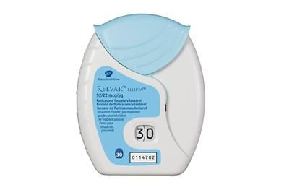 Ellipta

1. Hold the inhaler upright.
- Open the inhaler by sliding the cover down as far as it will go.
It will CLICK.
- Hold away from your mouth and breathe out gently.
- Put the inhaler between the lips and close lips firmly around it.
- Do not cover the air vent when holding the inhaler.
- Breathe in quickly & deeply through the mouth.
- Hold breath for as long as possible (about 3-4 seconds).
- Remove the inhaler from the mouth.
- Breathe out slowly and gently.
- Close the inhaler by sliding the cover upwards as far as it will go to cover the mouthpiece.
- Rinse the mouth with water if possible.
- If inhaler is opened and closed without inhaling, the dose will be lost. The lost dose will be held securely in the inhaler, it is not possible to accidentally take extra medicine.
- When fewer than 10 doses are left the counter shows half red. After the last dose the counter shows red and number 0 is displayed.
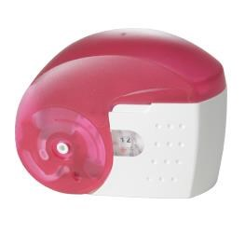

Nexthaler

- Hold the inhaler upright.
- Open the inhaler by sliding the cover down as far as it will go. It will CLICK.
- Hold away from your mouth and breathe out gently.
- Bring the inhaler to the mouth and place lips around the mouthpiece.
- Do not cover the air vent when holding the inhaler.
- Take a quick deep breath through the mouth. You may hear a click when you take a dose.
- Remove the inhaler from the mouth and hold the breath for 5 to 10 seconds or as long as is comfortable.
- Breathe out slowly.
- Move the inhaler back to the upright position and close the cover fully. Check the dose counter has gone down by one.
- Rinse the mouth with water if possible.
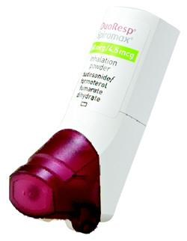

Spiromax

- Hold the inhaler with the mouthpiece cover at the bottom.
- Open the inhaler by folding it down until a CLICK is heard.
- Hold away from your mouth and breathe out gently.
- Place the mouthpiece between your teeth, and close the lips around the mouthpiece.
- Do not cover the air vent when holding the inhaler.
- Breathe in through the mouth as deeply and as hard as you can.
- Hold the breath for 10 seconds or as long as is comfortable. Remove inhaler from the mouth.
- Breathe out gently.
- Close the mouthpiece cover.
- Rinse the mouth with water if possible.
- Do not open and close the mouthpiece cover unless you are about to use the inhaler.
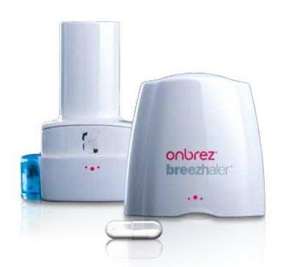
Breezhaler

- Pull off the cap.
- Hold the base of the inhaler firmly and tilt the mouthpiece to open the inhaler.
- With dry hands remove one capsule from the blister and place in the capsule chamber. Close the inhaler until you hear a CLICK.
- Hold the inhaler upright and pierce the capsule by firmly pressing together both side buttons at the same time. Do this only once. You should hear a click as the capsule is being pierced. Release the side buttons.
- Hold away from your mouth and breathe out gently.
- Place the mouthpiece in the mouth and close lips around the mouthpiece. When holding the inhaler, the side buttons should be facing left and right, do not cover the air vent.
- Breathe in rapidly and as deeply as you can. You should hear a whirring noise as the capsule spins around.
- Hold the breath for at least 5-10 seconds or as long as is comfortable.
- Breathe out gently.
- Open the inhaler to see if any powder is left in the capsule. If there is any powder left close the inhaler and repeat steps 5,6,7,8,9
- After finishing open the mouthpiece and remove the empty capsule.
Close the inhaler and replace the cap.
- Rinse the mouth with water if possible.
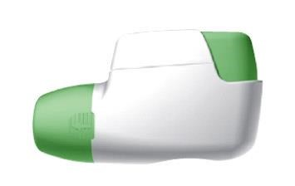

Genuair

- Remove the cap by lightly squeezing the arrows marked on each side and pull outwards.
- Hold the inhaler horizontally with mouthpiece towards you and the coloured button facing straight up.
- Press the button all the way down and then RELEASE it.
- Check the control window has changed to green.
- Hold away from your mouth and breathe out gently.
- Place the lips tightly around the mouthpiece.
- Breathe in strongly and deeply through the mouthpiece.
- You will hear a CLICK which signals you are using the inhaler correctly. Continue to inhale after you hear the click.
- Remove the inhaler from the mouth.
- Hold the breath for as long as is comfortable.
- Breathe out slowly through the nose.
- Check the control window has changed to red.
- If the control window is still green, repeat steps 7, 8
- Replace the protective cap.
- Rinse the mouth with water if possible.

