Eating Well with Pressure Sores or Leg Ulcers

Patient Information Leaflet

Introduction

A balanced diet is vital in combination with any medical treatment you may receive to help your pressure sores or leg ulcers heal. This leaflet provides you with advice and tips to help you get the most nourishment out of your meals and snacks.

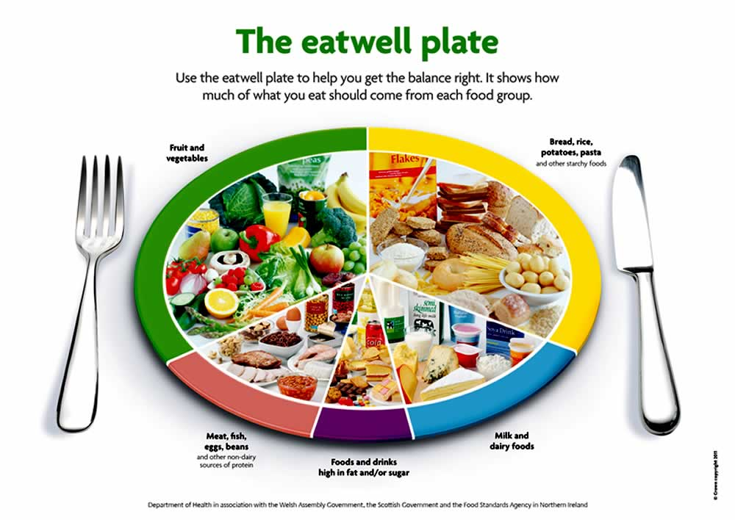

Eating well

- Base your meals on starchy foods such as bread, cereals, rice, pasta and potatoes. Choose wholegrain varieties whenever you can as they contain more fibre and are digested more slowly helping you feel fuller for longer. Starchy foods are a good source of energy, calcium, iron and B vitamins.

- Try to have at least 5 portions of a variety of fruit and vegetables every day. One portion equals 80g, a small handful or 3 heaped tablespoons of vegetables. Choose fresh, frozen, tinned or dried as they are rich in vitamins and minerals. These help to make new tissue to heal your pressure sores or leg ulcers.

  - Vitamin C helps with healing. Good sources include bell peppers, broccoli, brussel sprouts, strawberries, kiwis, oranges and pineapple.

  - Zinc also plays an important role in wound healing. Meat, salmon, dairy foods, beans, brown rice, potato and wholegrain cereals are rich in zinc.

- Aim for 3 portions of lean cuts of meat, fish, eggs and pulses (beans and lentils) every day. These are good sources of protein which will help to make new skin tissue. Cut off any visible fat from meat.

- Try to have a pint of milk a day or the equivalent e.g. a small pot of yoghurt, a piece of cheese (matchbox size) and 1/3 pint milk. These are also a good source of protein, vitamins and minerals. Choose reduced fat versions where possible.

- Limit your intake of foods high in saturated fat, sugar and salt.

Drinking well

This helps you to avoid becoming dehydrated. It also helps your wounds to heal. Aim for 6-8 glasses a day:

  - Keep a drink beside you at all times and sip it often.

  - Semi-skimmed/skimmed milk, hot chocolate, and Horlicks are all good choices. The protein in milk helps to heal wounds.

  - A small glass of fruit juice (not from concentrate) or smoothie is a good source of vitamins and minerals.

Main meal ideas Snack ideas Pudding ideas

Soup with chicken and vegetables  Scrambled eggs with toast and tinned tomatoes  Meat or lentil curry with vegetables and rice  Poached fish with white sauce, potatoes and garden peas  Shepherd’s pie with carrots  Sandwich with low fat cheese, egg, ham or fish | Apple/banana  Light yoghurt  Pitta or naan bread with pate or soft cheese and pickles  Light/low fat houmous with cracker/flatbread  Oatcakes with low fat cream cheese  Small slice fruit loaf  Fruit scone with low fat spread | Rice pudding, tapioca, semolina with added dried fruit  Light Custard with stewed apple  Frozen lower fat yoghurt with mixed berries  Low sugar jelly with fruit  Small pancake with fruit  Low fat yoghurt with strawberries

Additional Information

- Diabetes – High blood sugar levels can impair wound healing. Speak to your GP or Dietitian for advice on ways to control your levels.

- Multivitamin and mineral supplements – These may be recommended if your GP or Dietitian thinks you need them.

- Being overweight can affect your pressure sores or leg ulcers healing. If you are interested in managing your weight speak to your GP who can refer you to a Dietitian for advice.

Contact us

If you have any further questions about this leaflet the Dietitians contact details are shown below.

Acute Dietitians
Nutrition and Dietetic Services
Inpatient Therapies Department
Stepping Hill Hospital
Poplar Grove
Hazel Grove
Stockport
SK2 7JE
Tel: 0161 419 5087

Community Dietitians
Nutrition and Dietetic Service
Regent House
Heaton Lane
Stockport
SK4 1BS
Tel: 0161 426 5975

If you would like this leaflet in a different format, for example, in large print, or on audiotape, or for people with learning disabilities, please contact:
Patient and Customer Services, Poplar Suite, Stepping Hill Hospital. Tel: 0161 419 5678. Email: PCS@stockport.nhs.uk.

Our smoke free policy
Smoking is not allowed anywhere on our sites. Please read our leaflet 'Policy on Smoke Free NHS Premises' to find out more.

Leaflet number | Intranet Office will supply
Publication date | November 2012
Review date | November 2014
Department | Nutrition and Dietetics
Location | Inpatient Therapies, Stepping Hill Hospital

