|  |  |
| --- | --- |
| By Email | NHS South, Central and West (SCW)  Child Health Information Services  4th Floor,  Wat Tyler West,  Beckhampton Street,  Swindon, SN1 2JG |

Date 24/11/2023

Dear Colleague

New Contact Details: Child Health Information Services (CHIS)

As you will now be aware, SCW will be providing Child Health Information Services (CHIS) in the Greater Manchester region (Bolton, Bury, Oldham, Manchester, Rochdale, Salford, Stockport, Tameside, Trafford and Wigan) from 1 December 2023.

The processes you currently use will stay the same and you’ll be contacting the same CHIS staff, but the way you contact the CHIS team will change, and you will need to use the new telephone number and email address for your local team as detailed in the table below.

All areas HepB failsafe enquires should be directed to [scwcsu.GMFailsafe.chis@nhs.net](mailto:scwcsu.GMFailsafe.chis@nhs.net).

If you have any questions, queries or any concerns about this change, please get in touch with us at: [SCWCSU.CHIS.administration@nhs.net](mailto:SCWCSU.CHIS.administration@nhs.net)

The NHS Greater Manchester CHIS Team at SCW are very much looking forward to working with you and providing the same reliable service that you are used to.

Yours sincerely,

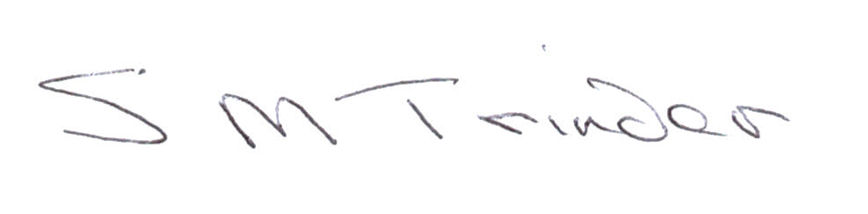

Sue Trinder

**CHIS Director**

SCW

|  |  |  |  |  |  |
| --- | --- | --- | --- | --- | --- |
| **Area** | **Previous Organisation** | **Location** | **Address** | **New Email address** | **New Telephone Number** |
| Manchester | Manchester University Foundation Trust | Parkway 5 | SCW CHIS, Parkway 5, Princess Road Manchester M14 7HR | [scwcsu.Manchester.chis@nhs.net](mailto:scwcsu.Manchester.chis@nhs.net) | 0300 561 0294 |
| Bury | Northern Care Alliance | Brook House | SCW CHIS, Brook House, Oldham Road, Middleton, M24 1AY | [scwcsu.burychildhealth.chis@nhs.net](mailto:scwcsu.burychildhealth.chis@nhs.net)  Or for newborn screening: -  [scwcsu.newbornscreening.chis@nhs.net](mailto:scwcsu.newbornscreening.chis@nhs.net) | 0300 561 0294 |
| Heywood, Middleton and Rochdale | Northern Care Alliance | Brook House | SCW CHIS, Brook House, Oldham Road, Middleton, M24 1AY | [scwcsu.hmrchildhealth.chis@nhs.net](mailto:scwcsu.hmrchildhealth.chis@nhs.net)  Or for newborn screening: -  [scwcsu.newbornscreening.chis@nhs.net](mailto:scwcsu.newbornscreening.chis@nhs.net) | 0300 561 0294 |
| Bolton | Northern Care Alliance | Horton House | SCW CHIS, Horton House - Floor 2, 4 Hamilton St, Oldham OL4 1DE | [scwcsu.boltonchildhealth.chis@nhs.net](mailto:scwcsu.boltonchildhealth.chis@nhs.net)  Or for newborn screening: -  [scwcsu.newbornscreening.chis@nhs.net](mailto:scwcsu.newbornscreening.chis@nhs.net) | 0300 561 0294 |
| Oldham | Northern Care Alliance | Horton House | SCW CHIS, Horton House - Floor 2, 4 Hamilton St, Oldham OL4 1DE | [scwcsu.oldhamchildhealth.chis@nhs.net](mailto:scwcsu.oldhamchildhealth.chis@nhs.net)  Or for newborn screening: -  [scwcsu.newbornscreening.chis@nhs.net](mailto:scwcsu.newbornscreening.chis@nhs.net) | 0300 561 0294 |
| Salford | Northern Care Alliance | Horton House | SCW CHIS, Horton House - Floor 2, 4 Hamilton St, Oldham OL4 1DE | [scwcsu.salfordchildhealth.chis@nhs.net](mailto:scwcsu.salfordchildhealth.chis@nhs.net)  Or for newborn screening: -  [scwcsu.newbornscreening.chis@nhs.net](mailto:scwcsu.newbornscreening.chis@nhs.net) | 0300 561 0294 |
| Trafford | Northern Care Alliance | Horton House | SCW CHIS, Horton House - Floor 2, 4 Hamilton St, Oldham OL4 1DE | [scwcsu.gm.chis@nhs.net](mailto:scwcsu.gm.chis@nhs.net)  Or for newborn screening: -  [scwcsu.newbornscreening.chis@nhs.net](mailto:scwcsu.newbornscreening.chis@nhs.net) | 0300 561 0294 |
| Stockport | Northern Care Alliance | The Forum | SCW CHIS, The Forum, Tameside Business Park, Denton M34 3QS. | [scwcsu.stockportchildhealth.chis@nhs.net](mailto:scwcsu.stockportchildhealth.chis@nhs.net)  Or for newborn screening: -  [scwcsu.newbornscreening.chis@nhs.net](mailto:scwcsu.newbornscreening.chis@nhs.net) | 0300 561 0294 |
| Tameside | Northern Care Alliance | The Forum | SCW CHIS, The Forum, Tameside Business Park, Denton M34 3QS. | [scwcsu.tamesidechildhealth.chis@nhs.net](mailto:scwcsu.tamesidechildhealth.chis@nhs.net)  Or for newborn screening: -  [scwcsu.newbornscreening.chis@nhs.net](mailto:scwcsu.newbornscreening.chis@nhs.net) | 0300 561 0294 |
| Wigan | Wigan, Wrightington & Leigh | Platt Bridge Health Centre | SCW CHIS, Platt Bridge Health Centre, Rivington Ave, Platt Bridge, Wigan WN2 5NG | [scwcsu.childhealth.wwl.chis@nhs.net](mailto:scwcsu.childhealth.wwl.chis@nhs.net) | 0300 561 0294 |