Flu and COVID-19 vaccinations autumn/winter 2023-24

Social media toolkit
Eligible people are being urged to get their winter vaccinations for flu and COVID-19 as soon as possible for the best protection.
The adult COVID and flu vaccination programmes have been brought forward following the emergence of a new COVID-19 variant.
Eligible adults can book their COVID-19 vaccination now on the NHS App, on the NHS website or by calling 119 for free if they can’t get online.
Adults can book their flu vaccination through their GP practice or local pharmacy, and some people may be offered their vaccinations directly by a local NHS service.
The flu vaccine is also offered to most children who should get it as soon as they can for their protection and to help stop the virus spreading to others. The children’s flu vaccine is usually given as a quick and painless spray up the nose.
Flu and COVID-19 can be unpleasant. But for many people, particularly those with certain health conditions, older people and pregnant women, they can be very dangerous and even life-threatening. Catching both viruses over winter increases the risk of serious illness even further.
Vaccines are the best protection against both viruses so please share these posts on your social media as appropriate.

Social media

Image | Text | Alt text
General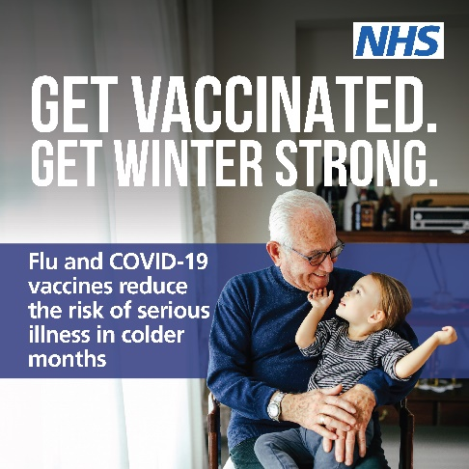 | For some people, flu or COVID-19 can be very dangerous and even life-threatening.  Flu and COVID-19 vaccines reduce the risk of serious illness in colder months.  Find out if you’re eligible and book now.  https://bit.ly/GMWinterVax | An older person sitting on a chair with their arms around a toddler who is sitting on their lap. They are smiling as they look at each other. Text: get vaccinated. Get Winter strong. Flu and COVID-19 vaccines reduce the risk of serious illness in colder months. Logo: NHS.
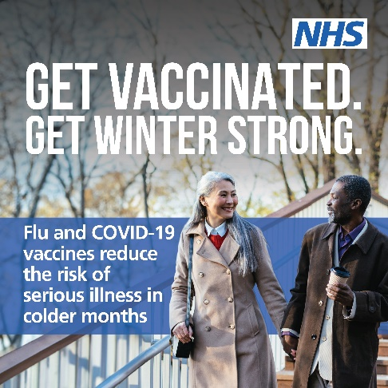 | For some people, flu or COVID-19 can be very dangerous and even life-threatening.  Flu and COVID-19 vaccines reduce the risk of serious illness in colder months.  Find out if you’re eligible and book now. https://bit.ly/GMWinterVax | Two people out doors wearing coats. They are chatting as they walk down stairs against a backdrop of winter trees. Text: get vaccinated. Get Winter strong. Flu and COVID-19 vaccines reduce the risk of serious illness in colder months. Logo: NHS.
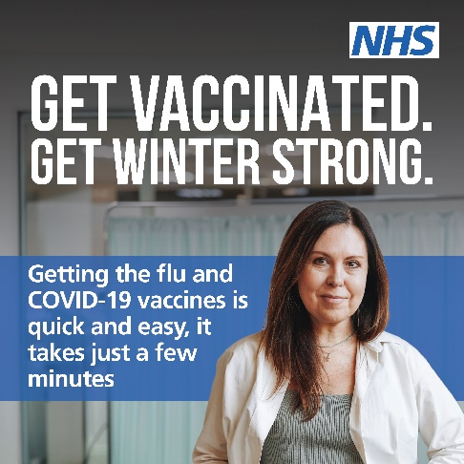 | Getting your flu and COVID-19 vaccinations is quick and easy — it takes just a few minutes.  Find out if you’re eligible and book now.  https://bit.ly/GMWinterVax | Head and shoulders shot of a smiling adult wearing a white medical jacket standing in front of a medical privacy screen. Text: get vaccinated. Get Winter strong. Getting the flu and COVID-19 vaccines is quick and easy, it takes just a few minutes. Logo: NHS.
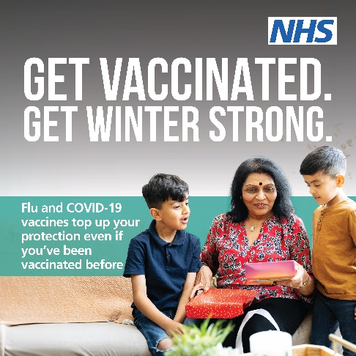 | Immunity from previous flu and COVID-19 vaccines fades, and the viruses change over time.  Top up your protection — even if you’ve had flu or COVID-19 or have been vaccinated before.  Check if you’re eligible and book now.  https://bit.ly/GMWinterVax | A person sitting on a sofa holding two wrapped presents. Two children are standing at either side of them. Text: get vaccinated. Get winter strong. Flu and COVID-19 vaccines top up your protection even if you’ve been vaccinated before. Logo: NHS.

Carers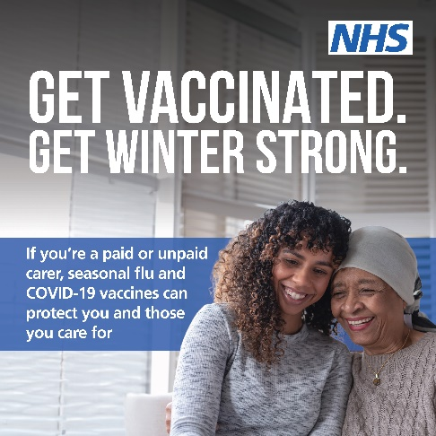 | If you’re a paid or unpaid carer, seasonal flu and COVID-19 vaccinations can protect you and those you care for.  Book now https://bit.ly/GMWinterVax | Head and shoulders shot of two smiling people standing side by side with their heads close together.  Text: get vaccinated. Get winter strong. If you’re a paid or unpaid carer, seasonal flu and COVID-19 vaccines can protect you and those you care for. Logo: NHS.
Underlying health conditions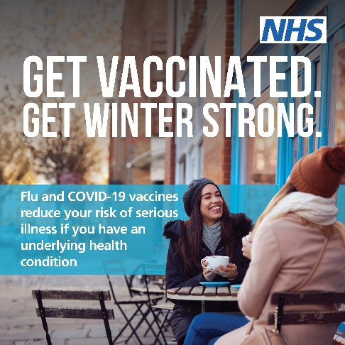 | Flu and COVID-19 vaccines reduce your risk of serious illness if you have an underlying health condition. Find out if you’re eligible and book now.  https://bit.ly/GMWinterVax | Two people wearing winter coats, scarves and hats sitting at a table outside a cafe. Text: get vaccinated. Get winter strong. Flu and COVID-19 vaccines reduce your risk of serious illness if you have an underlying health condition. Logo: NHS
Pregnant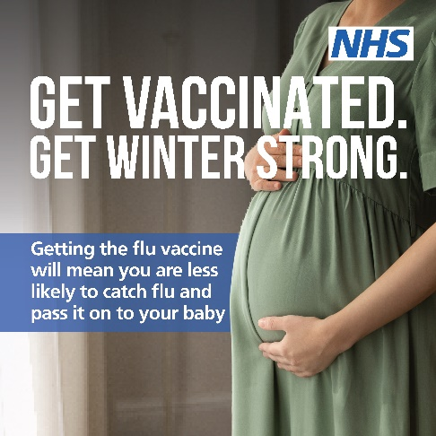 | Getting the flu vaccine will mean you are less likely to catch flu and pass it on to your baby.  Protect yourself and your baby this winter.  Find out more and book now. https://bit.ly/GMWinterVax | Close up of a pregnant person wearing a green dress and resting their hands on their baby bump. Text: get vaccinated. Get winter strong. Getting the flu vaccine will mean you are less likely to catch flu and pass in on to your baby. Logo: NHS.
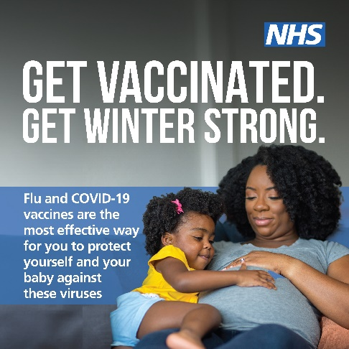 | Flu and COVID-19 vaccines are the most effective way to protect yourself and your baby against flu at any stage of your pregnancy.  Find out if you’re eligible and book now. https://bit.ly/GMWinterVax | A pregnant person sitting on a sofa cuddling a toddler, with one hand resting on their baby bump. Text: get vaccinated. Get winter strong. Flu and COVID-19 vaccines are the most effective way for you to protect yourself and your baby against these viruses. Logo: NHS.
Toddlers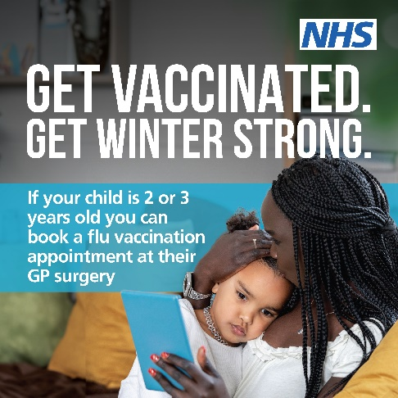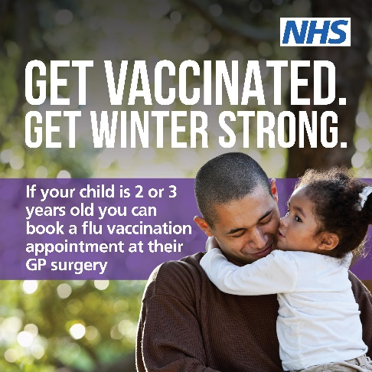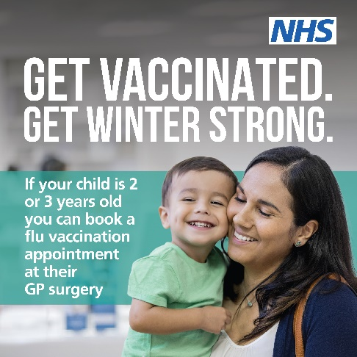 | If your child is 2 or 3 years old you can book a flu vaccination appointment at their GP surgery. Protect your child against flu this winter. Find out more https://bit.ly/GMWinterVax | Image 1  A person sitting on a sofa with a book in one hand. They are cuddling and kissing the head of a toddler who is sitting on their lap. Text: get vaccinated. Get Winter Strong. If your child is 2 or 3 years old you can book a flu vaccination appointment at their GP surgery. Logo: NHS.  Image 2  Head and shoulders shot of a smiling person carrying a toddler against a background of winter sunlight filtering through trees. Text: get vaccinated. Get Winter Strong. If your child is 2 or 3 years old you can book a flu vaccination appointment at their GP surgery. Logo: NHS.  Image 3  Head and shoulders shot of a smiling person carrying a toddler. Text: get vaccinated. Get Winter Strong. If your child is 2 or 3 years old you can book a flu vaccination appointment at their GP surgery. Logo: NHS
Social media graphics should include alt text so people who use screen readers can access the content of an image.

All assets can be found on the following download links:
Dropbox: https://www.dropbox.com/sh/jqb3x3m01b3t3ix/AABRG1_ZExLd_Kh34MWfEgvra?dl=0
Google Drive:
https://drive.google.com/drive/folders/1e5f76UTknXo_Od94YuvRYAOJGaveQGd6?usp=drive_link

Please contact the NHS GM campaigns team if you have any problems downloading from these links – gmhscp.gm-campaigns@nhs.net.

