**Greater Manchester Medicines Optimisation for Lipid Management Offer FAQ**

**v.3 17.04.23**

**What is the offer?**

The aim of the offer is to assist in finding the patients at risk and validating them for lipid treatment that ensures better quality of care for all patients at the highest risk of harm. To drive down demand on already pressured GP by helping to look at existing lists and identify patients for intervention according to NICE guidance.

The service provides a flexible level of support, tailored to the organisational needs of the HCO and current capacity to implement the lipid management pathway and provides a platform through which these improvements can be achieved.

The objective of the funding is to:

* Provide clinical support tailored to the needs of the Recipient
* Review patients with atherosclerotic cardiovascular disease (“ASCVD”) at the highest risk of cardiovascular events in primary care, who are not achieving lipid targets, as specified in national guidance
* Provide therapeutic recommendations based on the AAC Lipid Management Pathway (or a localised version of the AAC Pathway)

**What can Interface help with?**

Interface aim to deliver the following key objectives:

**Pharmacist-led desktop review**

To support primary care healthcare organisations to identify and prioritise patients who have a diagnosis of ASCVD that are not receiving optimal lipid management in line with national and local lipid management pathways (based on non-achievement of expected reduction in LDL or non-HDL cholesterol), taking into account:

• ASCVD diagnosis and other relevant cardiovascular history

• Latest and historical lipid profile including TC, LDL and non-HDL levels

• Current and historical lipid management strategies

• Local or individual LHE guidance relating to workstream prioritisation

**Patient-facing clinics (virtual or face-to-face)**

To provide clinical capacity through Interface clinical pharmacists to deliver patientfacing or virtual optimisation clinics for defined cohorts of patients, to optimise lipid management in line local and national lipid management pathways and local health economy (LHE) defined management frameworks in order to:

• Provide educational and disease management support to people living with ASCVD

• Ensure that patients are treated appropriately and to optimise pharmacological lipid modification strategies for patients in line with the LHE defined management framework as well as non-pharmacological interventions including diet and lifestyle measures

**Support sustained quality improvement (QI) in lipid management**

To support sustained quality improvement in the adoption and implementation of the lipid management pathway across the health care organisation (HCO) through:

* Provision of a post clinic evaluation report detailing key outputs delivered by the service, allowing the HCO to evaluate the impact of the review and formulate a strategy for ongoing practice workstreams
* Assisting training staff within practices. Health care professionals within practice may accompany the Interface pharmacists in lipid optimisation clinics, providing mentoring opportunities, sharing best practice and sustaining an educational and process legacy.

The funding will cover patients using the cohort criteria of the Greater Manchester CVD Prevention Lipid Management case finding tool, specifically:

* Cohort 1- had a CVD event, not on a statin
* Cohort 4a- had a CVD event, statins maximised, eligible for injectables (LDL-C greater or equal to 2.6 mmol/l)
* Cohort 4b- had a CVD event, statins maximised, not eligible for injectables (LDL-C greater or equal to 1.8 mmol/L but less than 2.6 mmol/l)

**How was the funding approved?**

The priority for secondary prevention lipids optimisation of highest risk patient cohorts was agreed by the Greater Manchester Clinical Effectiveness Group and the ICB. Improving cardiovascular health and reducing cardiovascular mortality is now a [priority for Greater Manchester](https://www.england.nhs.uk/north-west/wp-content/uploads/sites/48/2023/02/Greater-Manchester-Recovery-and-Prevention-Plan_final.pdf). The GM system level lipid optimisation workforce offer has been endorsed in this context by the Greater Manchester CVD Prevention Oversight Group and is part of the wider NHS England lipids optimisation programme.

**Interface protocol**

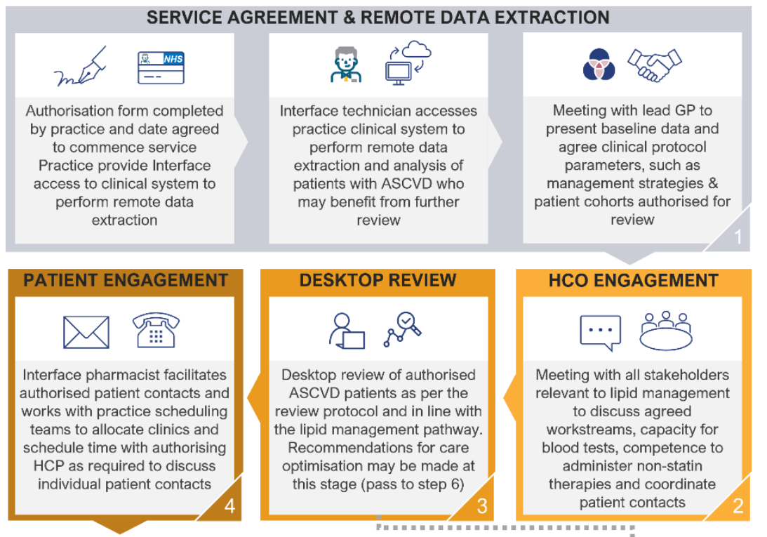

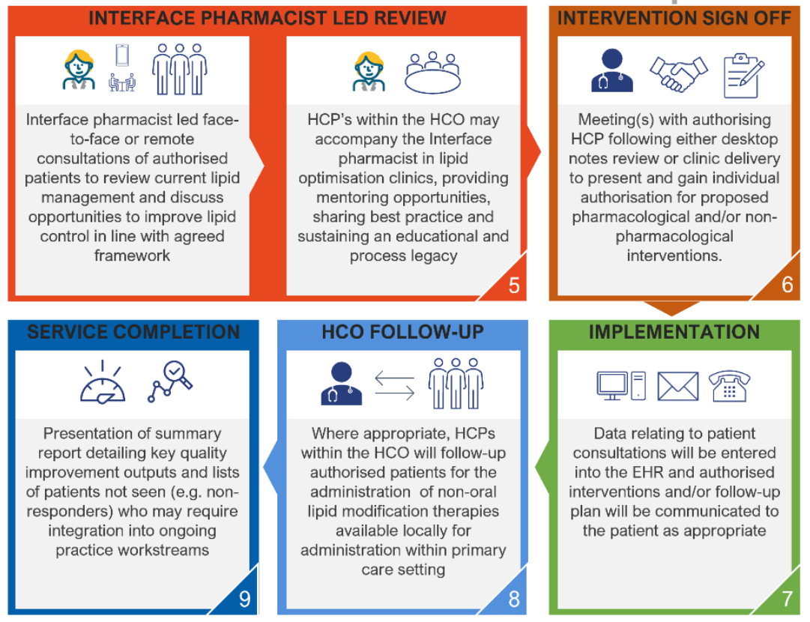

**Will Interface follow local guidelines?**

Yes, Interface will follow local guidance for prescribing as indicated by GMMMG and the [Greater Manchester Lipid Management Pathway for Secondary Prevention of CVD](https://gmmmg.nhs.uk/wp-content/uploads/2023/02/Lipid-Management-Pathway-for-Secondary-Prevention-of-Cardiovascular-Disease-CVD-21.12.22.pdf), using the [Greater Manchester lipid management case finding tool](https://healthinnovationmanchester.com/cvdprevention-lipidpathway-resources/), specifically:

•Cohort 1- had a CVD event, not on a statin

•Cohort 4a- had a CVD event, statins maximised, yet not to target, eligible for injectables (LDL-C greater or equal to 2.6 mmol/l)

•Cohort 4b- had a CVD event, statins maximised, yet not to target, not eligible for injectables (LDL-C greater or equal to 1.8 mmol/L but less than 2.6 mmol/l)

Interface implementation:

* Provide initial set up with recipient practice
* Conduct database searches & review patients following the Greater Manchester Lipid Management Pathway
* Facilitate patient contact
* Delivery virtual of face-to-face patient reviews & provide treatment recommendations following GM pathway
* Practice staff can accompany Interface for mentoring opportunities for lipid management

**How will Interface find eligible patients?**

Interface will use the Greater Manchester lipid management case finding tool, which is already embedded in EMIS, SystmOne and Vision clinical systems across Greater Manchester. The search can be found in the data quality folder, titled ‘CVD Prevention: Lipid Management’

Guidance documents for the case finding are available on Health Innovation Manchester's [website.](https://healthinnovationmanchester.com/cvdprevention-lipidpathway-resources/) Interface will be working through: *‘Cohort 1, had a CVD event, not on a statin’*, *‘Cohort 4a- had a CVD event, statins maximised, yet not to target, eligible for injectables (LDL-C greater or equal to 2.6 mmol/l)’* and *‘Cohort 4b- had a CVD event, statins maximised, yet not to target, not eligible for injectables (LDL-C greater or equal to 1.8 mmol/L but less than 2.6 mmol/l)’*

**What is needed from the practice?**

Here is a breakdown of the review into three phases so you get an understanding of the GP’s/prescriber time that Interface will require on each day and what they need to be processed before they start the support before the first screening day:

**Before the screening day we will require:**

* An authorisation form signed by an authorised GP (This will be sent via Adobe Sign).
* Remote access granted for one of my technicians and pharmacist onto your computer systems.
* (This review can be completed in practice or remotely – practice preference of what they would prefer).

**1 Screening Day** - On this day, we will need to speak to an authorised GP for **30 mins around 11:00am** to discuss to protocol of the review.

**X Desk Top Day** – On this day, we will need to speak to an authorised GP for **20 minutes around 16:00pm** for a debrief (the amount of Desk Top days will depend on your patient list size eligible for this review).

**X Clinical Days** - On these days, they will need to speak to a GP or a prescriber for **20 minutes around 16:00pm** to discuss the individual patient recommendations (the amount of clinic days will depend on your patient list size eligible for this review).

**Can Interface prescribe?**

Yes, Interface can issue prescriptions for oral lipid management treatments e.g., statins & ezetimibe. Any of our recommendations will be approved by either a GP or a prescriber from the clinical meeting we will have at the end of each clinic day. Once approved, we can make changes on your behalf on the systems.

Interface will work through the clinical framework for the cohort groups and provide recommendations if patients are eligible for non-oral lipid treatments or other medication out of scope of the offer.

**When will Interface start? & How long will the clinics run for?**

Interface aim to provide one clinic a week minimum, this is flexible with the practice, the clinic will be on the same day each week.

Clinics run from 9-12pm and 1-4pm, with a 20-minute consultation per patient, with approximately 15 appointments per day.

Length of the support will depend on patient numbers for the cohorts and start date will depend on completion of the document authorisation and screening day.

**If a patient is eligible for an injectable lipid treatment how will be patient be booked into a clinic? & What is expected of the practice?**

If a patient is eligible for an injectable lipid treatment Interface will discuss the recommendation with the GP or prescriber in the 20-minute discussion at the end of the clinic day for the prescription to be issued.

Interface will conduct the patient consent and refer the patient for an appointment booking for the patient to have the injection (we can assist and are flexible with different approaches based off practice preference – this can be discussed at the protocol meeting on day 1).

**The practice staff will be needed to administer the injection to the patient.** These can be in vaccine style clinics at the practice, as the patient would be consented for the appointment. Inclisiran is administered as a subcutaneous injection, this can be given by a practice pharmacist, nurse, physicians associate or GP. There are education webinars on inclisiran prescribing and administration [here](https://healthinnovationmanchester.com/cvdprevention-lipidpathway-resources/).

The practice will be responsible for ordering and reimbursement cost of inclisiran. Information can be found on [GMMMG](https://gmmmg.nhs.uk/wp-content/uploads/2022/11/Inclisiran-prescribers-information-leaflet-13.10.22-for-web.pdf) and [Health Innovation Manchester’s](https://healthinnovationmanchester.com/cvdprevention-lipidpathway-resources/) website.

Interface will follow GMMMG guidelines for [inclisiran prescribing](https://gmmmg.nhs.uk/wp-content/uploads/2022/11/Inclisiran-prescribers-information-leaflet-13.10.22-for-web.pdf).

**What is the sustainability of the offer?**

Health care professionals within the practice may accompany the Interface pharmacist in lipid optimisation clinics, providing mentoring opportunities, sharing best practice and sustaining an educational and process legacy.

**A PCN has another workforce offer, are they the same?**

Yes, this offer is a matched offer to another lipid management workforce offer that was open for applications in November 2022. Both workforce offers use Interface Clinical Pharmacists and follow the same clinical framework, local guidelines and cohorts (1 and 4 as listed above).

The only workforce offer open for applications is the Greater Manchester Medicines Optimisation for Lipid Management offer.

**How has this been funded?**

The service is provided as a donation of services funded by Novartis Pharmaceuticals UK Limited (“Novartis”) and delivered by Interface Clinical Services. Novartis has approved the associated materials in line with the ABPI Code of Practice. Please see the Clinical Protocol for further information.

This non-promotional therapy review service supports healthcare organisations (HCOs) to accelerate the proactive review of patients requiring lipid optimisation for secondary prevention of ASCVD in line with national and local lipid management pathways, through provision of clinical pharmacist capacity.