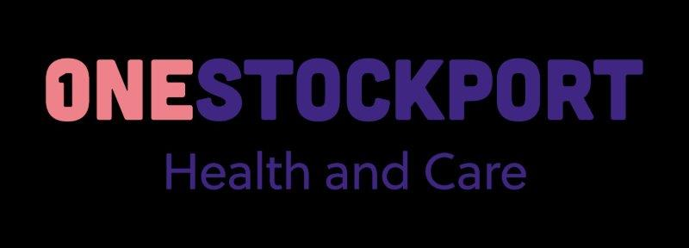

**Stockport Community Neurological Rehabilitation Service - CNRS**

We are pleased to advise that following a formal review of the current Community Neurological Rehabilitation Service pathway, approval has been given to increase the capacity of this service and streamline the pathway for provision to a single provider model. The impact of these changes will result in an equitable offer for Stockport patients.

These changes mean that from 1st April 2023 patients requiring clinic-based physiotherapy treatment will be provided by Stockport Foundation Trust CNRS team (formerly provided by Neurological Physiotherapy team) in several clinic spaces across Stockport.

The above service changes will not impact the current referral process and all referrals need to be completed as before. The CNRS team will continue to triage referrals ensuring that all patients receive treatment in the appropriate setting in a timely manner.

As of the 1st of April, Neurological Physiotherapy will continue to treat any patients still active on their caseload until treatment has been completed and the patient has been discharged from the service

Should you have any queries relating to the above please contact Tania Ravenscroft, Commissioning Lead for Community Services [Tania.ravenscroft@nhs.com](mailto:Tania.ravenscroft@nhs.com).

For clinical queries relating to specific patients please contact Christine Hyde, Team Lead [Christine.Hyde@stockport.nhs.uk](mailto:Christine.Hyde@stockport.nhs.uk) or Catherine McKenna, Operational Pathway Lead Therapies [catherine.mckenna@stockport.nhs.uk](mailto:catherine.mckenna@stockport.nhs.uk)