**Stockport and East Cheshire Medical Examiner’s Service:**

**Community - Stockport**

**Introduction and overview**

Medical examiner offices across Stockport and East Cheshire (hosted by Stockport NHS Trust) now provide independent scrutiny of all adult non-coronial deaths occurring in their hospitals.

The role of these offices is now being extended to also cover deaths occurring in the community.

Medical examiner offices are led by medical examiners, senior doctors from a range of specialties including general practice, who provide independent scrutiny of deaths not taken at the outset for coroner investigation. They put the bereaved at the centre of processes after the death of a patient, by giving families and next of kin an opportunity to ask questions and raise concerns. Medical examiners carry out a proportionate review of medical records and liaise with doctors completing the Medical Certificate of Cause of Death (MCCD).

Medical examiners are already delivering benefits outlined in the [National Medical Examiner’s 2020 report](https://www.england.nhs.uk/establishing-medical-examiner-system-nhs/#national-medical-examiner-reports), including fewer rejected MCCDs, improved referrals to coroners, improvements to patient care, and positive feedback from certifying doctors and bereaved people.

**Why is the process changing?**

The National Medical Examiner’s service is intended begin its statutory phase in April 2023 The statutory phase will mean that ALL non coronial deaths will have to be subject to ME scrutiny before an MCCD can be issued.

**What is the purpose of the Medical Examiner’s Service?**

The introduction of Medical Examiners was a key recommendation in several high profile independent enquiries

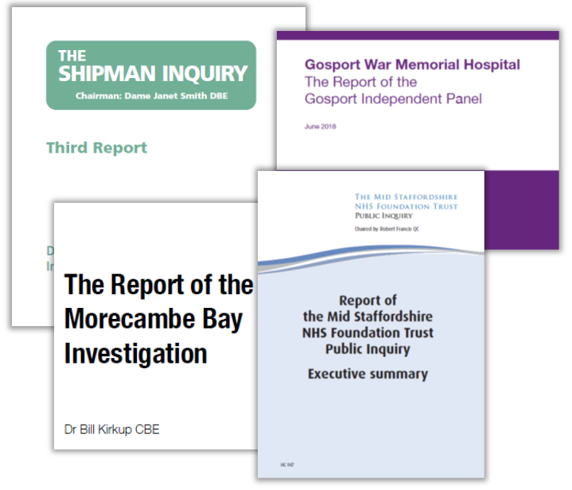

**Stockport GP Referral Process to Medical Examiners**

Patient dies within community / hospice

Yes

Police involved/suspicious circumstances/ coroner referral

No remit for Medical Examiner’s Office, GP Surgery to ensure Police / Coroner are aware

No

Qualifying Attending Practitioner (QAP) sends the Summary of Death Certification and copy of the patient’s Electronic GP Summary to Medical Examiner’s Office at: [Medicalexaminers.office@stockport.nhs.uk](mailto:Medicalexaminers.office@stockport.nhs.uk)

This must be received ASAP and at the latest by 2pm the next working day

Where the QAP is not available then another doctor can complete the summary but a doctor who saw the patient alive must be identified & listed on the summary

Medical Examiner carries out proportional scrutiny of records

Medical Examiner’s office gives the NOK an opportunity to ask questions or raise concerns and prepares file

Requirement to refer death to Coroner identified / confirmed and QAP emailed by Medical Examiner’s Office to inform them to refer to Coroner via existing protocols

Natural Cause of Death Established – Medical Examiner will liaise with the QAP regarding suggested changes, if any, to the cause of death and the wording of the MCCD is agreed. This will be confirmed by email to the QAP.

GP Surgery emails scanned copy of MCCD to Registrar ’s Office by email and copy to [Medicalexaminers.office@stockport.nhs.uk](mailto:Medicalexaminers.office@stockport.nhs.uk)

QAP completes MCCD with agreed cause of death

Medical Examiner’s office informs NOK finalised cause of death and opportunity to ask questions or raise concerns

Medical Examiner’s Office issues case reference number

GP Surgery inform NOK they can contact the Registrar

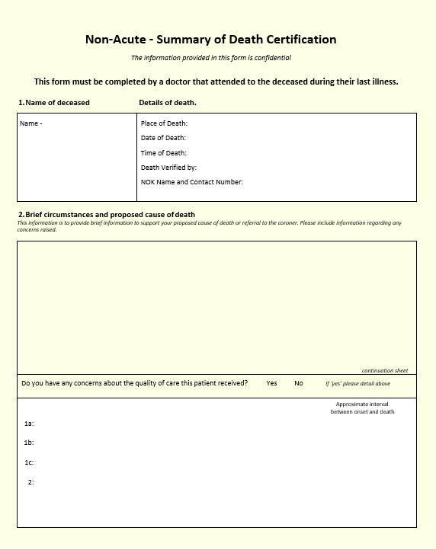**What information will the Medical Examiner’s service ask for?**

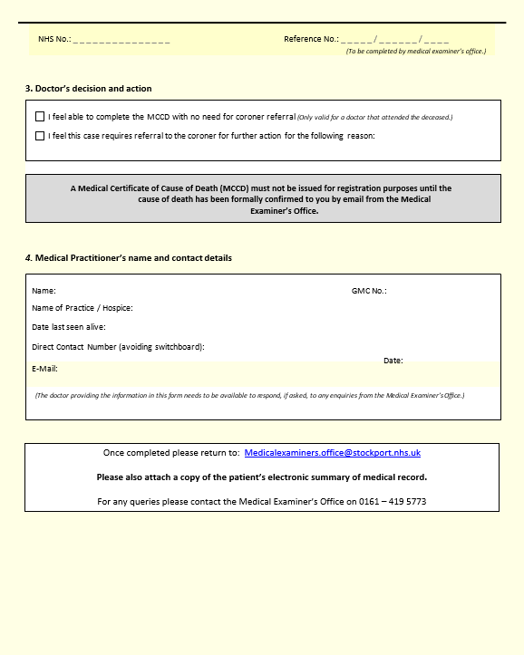

**Deaths requiring Urgent Release of Body:**

There may be a requirement for an urgent release of body i.e. expedited funeral on the basis of faith. The ME service will facilitate such circumstances and prioritises the scrutiny of these cases.

**Weekdays:** Please refer using the usual process, please ensure the ME team are notified that this is a requirement for urgent release.

**Weekends:** No current weekend service. Please refer to ME as per the usual process. The ME team will provide retrospective review/scrutiny.

**What does the ME Scrutiny involve?**

**Medical examiners seek to answer three questions:**

* What caused the death of the deceased?
* Does the coroner need to be notified of the death?
* Was the care before death appropriate?

**Medical examiners answer these by providing independent scrutiny, with three elements:**

* A proportionate review of relevant medical records
* Interaction with the doctor completing the Medical Certificate of Cause of Death
* Interaction with the bereaved, providing an opportunity to ask questions and to raise concern

**What else can the medical examiner service assist with?**

**Urgent release of the body:**

* Medical examiners have developed positive relationships within faith communities and will be able to support in the urgent issue of the MCCD.

**Supporting work with coroners’ offices:**

* Medical examiners are a source of medical advice for coroners, which should reduce requests from coroners for GPs to discuss cases or to advise on wording.
* Support with notifications to the coroner.

**Complex cases:**

* Medical examiners will support the doctor completing the MCCD, drawing on their extensive knowledge gained through training and regular exposure to more complex scenarios to support and advise.

**Learning:**

* A key objective for the medical examiner system is to identify constructive learning to improve care for patients.
* If issues are detected, medical examiners will offer non-judgmental feedback. Their aim is not to find fault or review in unnecessary detail.
* ***You can be assured of respectful and non-judgmental, independent scrutiny from the medical examiner’s service.***

**Feedback:**

* The ME service collate feedback and compliments which we will collate and provide to your practice. Other GP practices have already provided such feedback for CQC inspection.

**What Happens next:**

To prepare for the statutory requirement of the service in April 2023 please contact the Medical Examiners Office to arrange a start date.

The process has been piloted in Heald Green and at St Anne’s hospice with no negative feedback.

**Contact details for GP surgeries:**

|  |  |  |  |
| --- | --- | --- | --- |
| **Lead Medical Examiner** | **Dr James Catania** | Through SHH switchboard | James.catania@stockport.nhs.uk |
| **Lead Medical Examiner Officer** | **Ellie Skelton** | **0161 419 5727** | [ellie.skelton@stockport.nhs.uk](mailto:ellie.skelton@stockport.nhs.uk) |
|  |  |  |  |

|  |  |
| --- | --- |
| **GP Direct Numbers:** | **0161 419 5773** |
| **GP Direct Email Address:** | Medicalexaminers.office@stockport.nhs.uk |

**Useful information:**

**ONS/HMO guidance:**

<https://assets.publishing.service.gov.uk/government/uploads/system/uploads/attachment_data/file/1062236/Guidance_for_Doctors_completing_medical_certificates_Mar_22.pdf>

**Royal College of Pathology Cause of Death List:**

[G199-Cause-of-death-list.pdf (rcpath.org)](https://www.rcpath.org/uploads/assets/c16ae453-6c63-47ff-8c45fd2c56521ab9/G199-Cause-of-death-list.pdf)

**Royal College of Pathology Guidelines:**

[National_Medical_Examiner_-_good_practice_guidelines.pdf (england.nhs.uk)](https://www.england.nhs.uk/wp-content/uploads/2020/08/National_Medical_Examiner_-_good_practice_guidelines.pdf)

[Good-Practice-Series-BAME-paper.pdf (rcpath.org)](https://www.rcpath.org/uploads/assets/72675084-5ed3-43a1-b518c61395dd1194/Good-Practice-Series-BAME-paper.pdf)

[Good-Practice-Series-Urgent-release-of-a-bodyFor-Publication.pdf (rcpath.org)](https://www.rcpath.org/uploads/assets/3590bf7f-a43e-4248-980640c5c12354c4/Good-Practice-Series-Urgent-release-of-a-bodyFor-Publication.pdf)

**Other Resources:**

[Further information on the Medical Examiner's service](https://mft.nhs.uk/the-trust/other-departments/laboratory-medicine/information-for-gps/laboratory-medicines-newsletter-for-gps/medical-examiner-offices-to-cover-deaths-in-the-community/)

**Letter to GPs (June 2021):**

<https://www.england.nhs.uk/establishing-medical-examiner-system-nhs/non-coronial-deaths-in-the-community/>

**Frequently Asked Questions:**

**How will Medical examiner benefit primary care?**

Medical examiners are already delivering benefits outlined in the National Medical Examiner’s 2020 report, including fewer rejected MCCDs, improved referrals to coroners, improvements to patient care, and positive feedback from certifying doctors and bereaved people. Potential benefits for GPs include:

* **Supporting the bereaved**: For GPs, this can reduce workload by taking care of enquiries and follow-ups. This does not replace GPs speaking with families or next of kin and providing the support they wish to give.
* **Support with MCCD completion**: specialist training and understanding of the MCCD and death certification processes means medical examiners can reduce the burden associated with coroner notifications from GP practices.
* **Supporting work with coroners’ offices**: medical examiners are a source of medical advice for coroners, which should reduce requests from coroners for GPs to discuss cases or to advise on wording.

**Will this increase my workload?**

In addition to the benefits described above, the referral process has been designed tominimally impact on workload as much as possible. Having a streamlined process setup within practices can reduce any administrative burden with the initial referral process taking no longer than writing a hardcopy.

You will *not* need to refer cases to the Medical Examiners that you refer directly to His Majesty’s Coroners.

**This will delay the process of issuing MCCD?**

Although the ME process introduces an extra step as required by legislation, Community deaths will be prioritised by the ME office, and we will continue to look at service improvements as we do in the acute setting.

**This process may create more complaints for us?**

We have found that the process improves family experience in that they can have a conversation with a member of the ME team and are given the opportunity to ask questions of an independent party. This can help relieve concerns and actually prevent unwarranted complaints.

**Will the ME complete the MCCD:**

The GP will still be responsible for the issue of the MCCD and any funeral paperwork that is required. ME will support GPs with establishing an accurate cause of death

This does not replace GPs speaking with families or next of kin, providing the support they wish to give.