Social media schedule – One Stockport Hub From 1st – 11th February

Wednesday, 1 February  There's just two more chances to get a Covid booster at One Stockport Hub vaccination clinic, SK1 1RA  Those eligible can get it Sat 4th Feb, or Sat 11th Feb, 9.30am-3.30pm  It follows the announcement that the booster programme will pause on 12 Feb  More at https://orlo.uk/zFlJN | 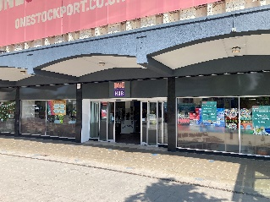
Thursday, 2 February  Now's the time for over 50s to get the winter Covid booster, as the booster programme pauses from Feb 12th.  One Stockport Hub vaccination clinic, Mersey Sq, SK1 1RA, has two sessions left on Sat 4th Feb, and Sat 11th Feb, 9.30am-3.30pm.  More info: www.stockport.gov.uk/vaccinations | 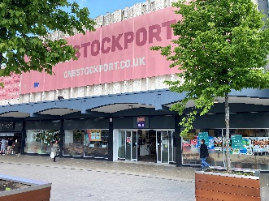
Friday, 3 February

If you’re aged 50+ time is running out to get your winter Covid booster.
One Stockport Hub vaccination clinic, Mersey Sq, is open for just two more Saturdays – 4 Feb and 11 Feb, 9.30am to 3.30pm.
Just walk in, no appointment needed.
www.stockport.gov.uk/vaccinations

Saturday, 4 February  8.30am:  One Stockport Hub Covid vaccination clinic in Mersey Sq, SK1 1RA, is open today (4 Feb), 9.30am - 3.30pm.  If you’re aged 50+ make sure you’ve had your winter booster.  Covid is still here, and the vaccination will protect you from becoming seriously ill.  www.stockport.gov.uk/vaccinations  11.30am:  There’s still time for anyone 50+ to get the winter Covid booster at One Stockport Hub today (4 Feb).  Open until 3.30pm at Mersey Sq, SK1 1RA.  Walk in, no appointment needed.  Those aged 5+ can also get a 1st, 2nd, or booster vaccination if eligible. www.stockport.gov.uk/vaccinations | No image
Sunday, 5 February  Covid and flu are still hanging around.  If you have a long-standing medical condition, you're at greater risk if you catch them.  Protect yourself - get your free vaccinations now.  Find out how to book yours today at www.gmintegratedcare.org.uk/get-my-jab  #GetVaccinatedGM | 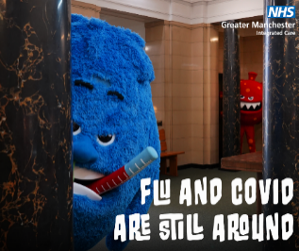
Monday, 6 February  You can’t hide from flu and Covid.  Free Covid-19 booster and flu vaccines are available now to protect you from the worst effects of both viruses.  See if you're eligible and book yours today via  www.gmintegratedcare.org.uk/get-my-jab  #GetVaccinatedGM | 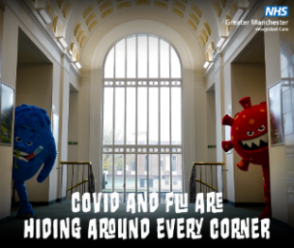
Tuesday, 7 February  Flu and Covid are still around.  Stop them in their tracks with a free Covid-19 jab and flu vaccine.  Check eligibility and sort yours today at www.gmintegratedcare.org.uk/get-my-jab  #GetVaccinatedGM | 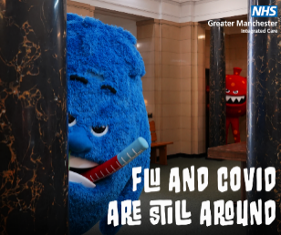
Wednesday, 8 February

There’s just one more chance for over 50s to get the winter Covid booster at One Stockport Hub pop-up vaccination clinic this Saturday (11th Feb). After this date it will be closed. It’s open 9.30am-3.30pm at Mersey Sq, Stockport, SK1 1RA.
www.stockport.gov.uk/vaccinations

Thursday, 9 February

Last chance before Covid booster programme pauses.
If you need the winter booster, especially over 50s, get it Sat (11 Feb) 9.30am to 3.30pm at One Stockport Hub, Mersey Sq, Stockport, SK1 1RA.
The clinic will close until further notice after this date.
www.stockport.gov.uk/vaccinations

Friday, 10 February  Tomorrow (11th Feb) is the last chance for over 50s to get the Covid booster at One Stockport Hub vaccination clinic, before it closes.  Don’t miss the last chance to get the booster to protect you from becoming seriously ill. Open 9.30am to 3.30pm.  www.stockport.gov.uk/vaccinations | No image
Saturday, 11 February  8.30am:  Final day (11 Feb) to get a Covid booster at One Stockport Hub vaccination clinic (Mersey Sq, SK1 1RA), 9.30am - 3.30pm.  If you’re 50+ make sure you’ve had your winter booster.  Covid is still here and vaccination will protect against serious illness.  www.stockport.gov.uk/vaccinations  11.30am:  Last call for anyone 50+ to get a winter Covid booster at One Stockport Hub clinic today (11 Feb), before it closes for the pause in the national booster programme. Open until 3.30pm - Mersey Sq, SK1 1RA. Those aged 5+ can also get a 1st,2nd,or booster vaccination if eligible. | No image

