Greater Manchester Palliative and End of Life Care
A new website to support professionals

This pack is aimed at communications professionals across health and care services in Greater Manchester. You will find information to help you promote the new Greater Manchester Palliative and End of Life Care website to staff.

Contents

1. Background | Page 1
2. Audience | Page 2
3. Website contents | Page 2
4. Key messages | Page 2
5. Graphic | Page 3
6. Internal newsletter copy | Page 3
7. Social media posts | Page 4
8. Contact details | Page 4

1. Background

The Palliative and End of Life Care Network is one of eight clinical networks within the Greater Manchester and Eastern Cheshire Strategic Clinical Networks. It is clinically led by Dr David Waterman, Consultant in Palliative Medicine, Stockport NHS Foundation Trust and St. Ann’s Hospice and Dr Liam Hosie, GP in Wigan Borough.

The network supports localities in Greater Manchester with work that helps to achieve the Greater Manchester Commitments to palliative and end of life care and the national outcomes of improving access, quality and sustainability. We do this by offering opportunities to connect with colleagues to share knowledge, expertise and best practice and encourage innovation.

A new website has been developed by the network to support communications with localities and professionals, share information and provide relevant and up to date resources in a timely and accessible manner. It is designed to be a useful ‘one-stop’ resource for professionals working within Greater Manchester

2. Audience

The website is aimed at professionals working within palliative and end of life care across the health and carer system, or those with an interest in the area.

Although it is not intended to be a resource for the public, there is a Frequently Asked Questions (FAQs) that would answer some common questions and direct members of the public to further information and resources.

3. Website contents

Section
About Us | Find Information | Get Involved
- Greater Manchester Commitments  - Strategic Clinical Networks  - Organisational structure  - Working groups  - Projects and programmes  - Meet the team | - Join a group  - Come to an event or training  - Have your say  - Join up for the professional’s newsletter | - Information, evidence, and resources  - FAQs for patients, carers, and families

4. Key messages

- The Greater Manchester (GM) Palliative and End of Life Care Network is led by Dr David Waterman, Consultant in Palliative Medicine, Stockport NHS Foundation Trust and St. Ann’s Hospice and Dr Liam Hosie, GP in Wigan Borough. Working with colleagues they use their expertise to support localities in GM to improve palliative and end of life services in the region.
- A new website has been launched to support professionals working in palliative and end of life care. It is a ‘one-stop’ resource where professionals can find information, advice and practical resources to support palliative and end of life care.
- The website can be accessed through the GM Integrated Care website or via this link peolc.net
- This is a resource for and by Greater Manchester professionals. If you have any upcoming events or resources you want to share, please don’t hesitate to get in touch with Lynne Partington, Programme Manager, lynne.partington1@nhs.net.
- Whilst the website is aimed at professionals, there is a Frequently Asked Questions (FAQs) section aimed at the public which will direct them to more appropriate resources.

5. Graphic

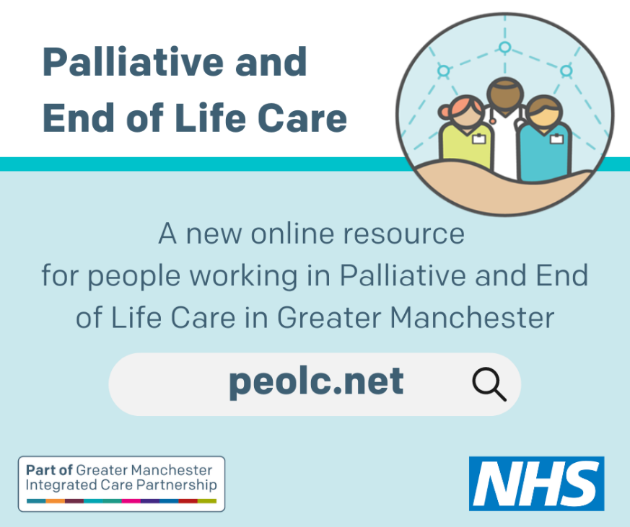

6. Internal newsletter copy

A new resource for Palliative and End of Life Care

A new website has launched to support professionals working in Palliative and End of Life Care across Greater Manchester (GM). Visit: peolc.net

The resource has been developed by colleagues working in the GM Palliative and End of Life Care Strategic Clinical Network. Led by Dr David Waterman, Consultant in Palliative Medicine at Stockport NHS Foundation Trust and St. Ann’s Hospice and Dr Liam Hosie a GP in Wigan Borough, the network is responsible for improving services and outcomes for residents in GM.

On the website you’ll find information, advice and practical resources to support you to deliver excellent Palliative and End of Life Care.

This is a resource designed by professionals for professionals and if you want to get involved or have any feedback please contact lynne.partington1@nhs.net.

7. Social media posts

- A new resource has launched to support professionals working in Palliative and End of Life Care across Greater Manchester. Developed by @GMEC_SCN the site gives info, advice and resources to support #PallativeCare and #EndOfLifeCare Visit: https://peolc.net/
- To our followers working in Palliative and End of Life Care. A new website has launched in Greater Manchester to support professionals to deliver excellent #PallativeCare and #EndOfLifeCare @GMEC_SCN Visit: https://peolc.net/

8. Contact details

For information about the website contact Lynne Partington, Programme Manager, lynne.partington1@nhs.net

For information about this communications pack contact Rachel Richardson, Strategic Communications Lead, rachel.richardson23@nhs.net

