While You Wait – Supporting people on the waiting list
Communications Toolkit

Background

Greater Manchester (GM) is one of the areas hardest hit by COVID-19. There are currently over 508,000 people waiting for planned hospital care (as of August 2022) and reducing the backlog continues to be a priority for the health and care system.

In October 2021, While You Wait [whileyouwait.org.uk] launched to support people who are on the waiting list. The website is designed to provide people with information and advice, including things they can do to help manage their physical and mental health while they wait for their appointment or treatment.

We have been working with the Clinical Reference Groups that sit under the GM Elective Care Recovery and Reform Programme, to develop new content for the website for people waiting under the following specialties:
- Orthopaedics
- Gastroenterology
- Children’s surgery including dental
We are pleased to announce these sections have now launched.
This communications pack is designed to assist localities to promote the new sections to:
- Patients currently on those waiting lists
- General public
- Staff
Resources in this pack
You will find the following resources in this pack:
- A list of the content you can find in the new sections
- Key messages about While You Wait
- Article for newsletters and website (external focused)
- Newsletter item (internal, aimed at staff)
- Social media posts and graphics

1. Content in the new sections

All the procedure level content gives information and advice on what you can do while you wait and what to do if your health deteriorates while you wait, including signs and symptoms to look out for.

Orthopaedics | Gastroenterology | Children’s surgery including dental
- First outpatient  - Pre-operative assessment  - Surgical hubs approach  - Knee replacement  - Knee ligament  - Knee arthroscopy  - Hip replacement  - Shoulder replacement  - carpal tunnel  - MyRecovery App  - Further information and support | - First outpatient  - Gastroscopy  - Colonoscopy  - Flexible sigmoidoscopy  - CT Colonoscopy  - FibroScan  - Further information and support | - The little orange book – managing common childhood illnesses  - Managing pain  - Sepsis  - Mental health support  - Preparing your child for admission, including useful resources  - Children’s dental surgery  - Children’s urology  - Further information and support

2. Key messages

- In October 2021 we launched While You Wait (www.whileyouwait.org.uk) as a resource designed to support patients waiting for hospital treatment across GM.

- While You Wait providers further information and advice, along with handy resources, to help patients manage their physical and mental wellbeing while waiting for hospital care. The website includes where patients can find extra support online and provides a link to look up average waiting times on the current national tools.

- While You Wait is also designed to be a resource for staff working in health and care who encounter patients on the waiting list who need support.

- The website so far has had generic health information advice, but we have been working with clinicians across Greater Manchester to develop specialty sections for the following specialties:
  - Orthopaedics,
  - Gastroenterology,
  - Children’s surgery including dental.

- The new specialty sections will give people waiting under those specialties more tailored advice for their condition and advice on what they can do to manage while they wait.

3. Article for newsletter and websites (external, public & patients)

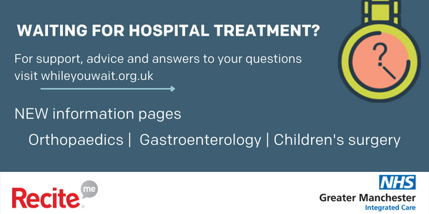

Waiting for hospital treatment?

While You Wait has information and advice to help you manage your physical and mental wellbeing.

Through our accessibility toolbar you can translate the content on While You Wait into over 100 languages, hear audio, change the colours, font type and size to suit your needs.

While You Wait now has additional information to support people waiting for treatment under Orthopaedics, Gastroenterology and Children’s services.

If you’re waiting for any of the following procedures listed below, you’ll find information about what to expect and what you can do during your waiting time to prepare and get the best possible outcome from your treatment.

You will also find information on what to do if your health is deteriorating including signs and symptoms to look out for that may indicate you need to seek medical help.

Orthopaedics
If you are waiting for any of the following procedures click here [Whileyouwait.org.uk/orthopaedics] to find more information and advice.

Knee replacement | Knee ligament | Knee arthroscopy | Hip replacement | Shoulder replacement | Carpal Tunnel

Gastroenterology
If you are waiting for any of the following procedures click here [Whileyouwait.org.uk/gastroenterology] for more information and advice

Gastroscopy | Colonoscopy | Flexible sigmoidoscopy | CT colonography | FibroScan

Children’s surgery
If your child is waiting for treatment click here [Whileyouwait.org.uk/childrens-surgery] to find more information about the following

Managing common childhood illnesses | Managing pain | Mental Health | Preparing for admission | Sepsis | Children’s urology services | Children’s dental services

4. Newsletter Item (internal staff comms)

While You Wait – Extra resources to support people waiting for hospital care and treatment

Approximately 1 in 6 people living in Greater Manchester (GM) are waiting for hospital care or treatment. Health and care organisations are working across the Greater Manchester Integrated Care Partnership to tackle the waiting list backlogs as quickly as possible.

While You Wait is a GM resource designed to support people while they are waiting for treatment. The resource answers some frequently asked questions and gives people advice on things they can do to look after their physical and mental wellbeing.

Through our accessibility toolbar people can translate the content into over 100 languages, hear audio, change the colours, font type and size to suit their needs.

Clinicians across NHS organisations in GM have helped to develop new pages for people waiting for treatment under the following specialties, Orthopaedics, Gastroenterology and Children’s surgery (including dental).

People waiting for any of the following procedure will find information about what to expect and what they can do during the waiting time to prepare and get the best possible outcome from their treatment. They will also find information on what to do if their health is deteriorating including signs and symptoms to look out for.

Please signpost patients waiting under these specialties to this information:

Orthopaedics
If you are waiting for any of the following procedures click here [Whileyouwait.org.uk/orthopaedics] to find more information and advice.

Knee replacement | Knee ligament | Knee arthroscopy | Hip replacement | Shoulder replacement | Carpal Tunnel

Gastroenterology
If you are waiting for any of the following procedures click here [Whileyouwait.org.uk/gastroenterology] for more information and advice

Gastroscopy | Colonoscopy | Flexible sigmoidoscopy | CT colonography | FibroScan

Children’s surgery
If your child is waiting for treatment click here [Whileyouwait.org.uk/childrens-surgery] to find more information about the following

Managing common childhood illnesses | Managing pain | Mental Health | Preparing for admission | Sepsis | Children’s urology services | Children’s dental services

5. Social media posts and graphics

Twitter (short) | Facebook (long) |  | Graphic
Waiting for hospital treatment?  Visit #WhileYouWait for support and advice on managing your physical and mental wellbeing. You’ll also find answers to questions and concerns.  whileyouwait.org.uk | Currently waiting for a hospital appointment or treatment?  Visit While You Wait for support and advice on how to manage your physical and mental wellbeing while you wait.  You will also find answers to frequently asked questions which may help address any concerns.  Visit whileyouwait.org.uk |  | 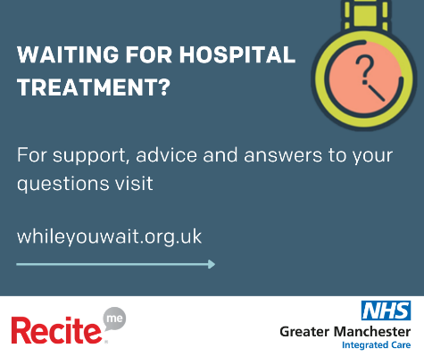
Waiting for treatment under Orthopaedic services?  Visit our new pages on #WhileYouWait for information on what to expect, how to prepare for your treatment and what to do if your health gets worse.  Visit: Whileyouwait.org.uk/orthopaedics | Are you waiting for treatment under Orthopaedic services?  Visit our new pages on While You Wait for information about:  - Your procedure and what to expect  - How you can use your waiting time to prepare for your treatment  - What to do if your health gets worse, including signs and symptoms to look out for  Includes information about first outpatient appointment, Pre-operative assessment, Surgical hubs, Knee replacement, Knee ligament, Knee arthroscopy,  Hip replacement, Shoulder replacement, carpal tunnel  Visit: Whileyouwait.org.uk/orthopaedics |  | 
Twitter (short) | Facebook (long) | Graphic
Waiting for a Gastroenterology procedure?  Visit our new pages on #WhileYouWait for information on what to expect, how to prepare for your procedure and what to do if your health gets worse.  Visit: Whileyouwait.org.uk/gastroenterology | Are you waiting for a Gastroenterology procedure?  Visit our new pages on While You Wait for information about:  - Your procedure and what to expect  - How you can use your waiting time to prepare for your treatment  - What to do if your health gets worse, including signs and symptoms to look out for  Includes information for Gastroscopy, Colonoscopy, Flexible sigmoidoscopy, CT Colonoscopy and FibroScan  Visit: Whileyouwait.org.uk/gastroenterology | 
Is your child waiting for hospital treatment?  Visit our new pages on #WhileYouWait for information on how to help your child, how to prepare for treatment and what to do if their health gets worse.  Visit: Whileyouwait.org.uk/childrens-surgery | Waiting for treatment under Orthopaedic services?  Visit our new pages on #WhileYouWait for information about:  - How to manage common childhood illnesses and manage pain  - Sepsis and signs to look out for  - How to help your child prepare for admission  - Dental services and how to look after their teeth  - Urology procedures  Visit: Whileyouwait.org.uk/childrens-surgery | 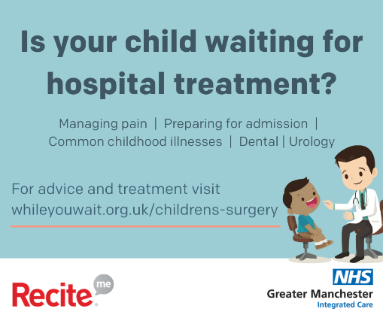

Contact us

For more information about While You Wait please contact:

Rachel Richardson, Strategic Communications Lead GM Elective Care Recovery and Reform Programme,
Rachel.richardson23@nhs.net

