Options for Practices to adopt Inclisiran into their Lipid Management Pathways
This document is intended to help practices and Primary Care Networks make an informed decision on how to introduce Inclisiran into their Lipid Management Pathways by illustrating the step by check process
Background
The NHS Long Term Plan identifies cardiovascular disease as a clinical priority and the single
biggest area where lives can be saved over the next 10 years.

The challenge: Despite significant efforts and initiatives by the health care system, the number of people dying prematurely from cardiovascular disease (CVD) is on the rise for the first time in 50 years
There is clear evidence that cholesterol, and specifically low-density lipoprotein cholesterol (LDL-C) is a well-established modifiable risk factor in the prevention of CVD. It is also well documented that sustained lowering of LDL-C can reduce the risk of cardiovascular events.

Introducing inclisiran: will form part of the lipid management pathway, providing an additional option for clinicians and patients in the management of cholesterol.
A Population health management approach aims to improve the health and wellbeing of an entire population while reducing health inequalities. This approach will build on the momentum already generated by AHSNs and clinicians in the optimisation of lipid management.
To achieve the scale and volumes required to positively impact a nation’s CV health, support the NHS Long term Plan ambitions and address challenges within the pathway, it is proposed that inclisiran initiation and management is carried out within the primary care setting by the primary care workforce where this patient
population is managed and cared for.
Primary Care implementation is essential to achieving a large – scale change in lipid management for patients with ASCVD

Currently, there are three classes of lipid-lowering medicines in the clinical pathway endorsed by NICE for optimal management of patients with hypercholesterolaemia: -
- High intensity statins: available as generic medicines which can be prescribed and administered in primary care
- Ezetimibe for use as an adjunct when statin monotherapy is ineffective, or monotherapy for those intolerant to statins
- PCSK9 inhibitors which are cholesterol absorption inhibitors and offer an added LDL cholesterol reduction of 15-20%. PCSK9i can be used with statins or independently for those intolerant to statins. They can be self-administered by patients with free homecare service available.

Inclisiran provides another option for treatment.

Options for introducing Inclisiran

There are two options for the introduction of Inclisiran into the Lipid Management Pathway. These are: -
- A proactive approach
- Opportunistic approach

Benefits from a Proactive Approach: -

- Earlier detection and intervention in high-risk conditions such as raised cholesterol, population health management could make a meaningful difference to the outcomes of patients
with elevated LDL-C
- Primary care, where CVD is predominantly managed, is pivotal for identification, treatment and referral of patients at risk
- Inclisiran, delivered through a population health program in primary care, could introduce a different approach to treating CVD and help the NHS meet the LTP goals
- Improving the detection of high lipid levels in patients, and helping to ensure they receive appropriate therapy to optimise lipid levels once detected, will have significant benefits for individuals, their families and the healthcare system
- Currently, it is recognised that there is inadequate optimisation of lipid therapy in high- and very-high risk patients across primary and secondary care
- Patients who are unable to tolerate, or do not respond to, established treatments such as statins are not being considered for second-stage treatments such as ezetimibe or PCSK9 inhibitors
The NHS Long Term Plan calls for a proactive PHM approach to the identification and treatment of high-risk patients to help prevent cardiovascular disease
- to Improve and support patient adherence to treatment regime and lifestyle changes.
- Provide ongoing opportunity for shared decision-making and support for patients

Benefits from an Opportunistic Approach

Patients will generally be identified when they visit their practice for a health check or for other treatment. The lipid optimisation case finding tool, which has been developed by NHS Digital, will be incorporated into the GP clinical systems and should flag up any patient suitable for lipid optimisation, or for prescribing Inclisiran to manage cholesterol levels.

This approach will require less demands on practice time but to be successful, it is important that the introduction of inclisiran is embedded with other local programmes that will facilitate its adoption.
For example, programmes commissioned by NHSEI, ICSs, public health in local authorities etc.
By enabling earlier intervention in high-risk conditions such as raised cholesterol, we believe a PHM could make a meaningful difference to the outcomes of patients with elevated LDL-C
PCNs will also be expected to think about the wider health of their population, taking a proactive approach to managing population health and assessing the needs of their local population to identify people who would benefit from targeted, proactive support.
Primary care teams will need to collaborate; sharing staff and resources to ensure the best care for individual patients.
- Ensure patients are on optimal medication to reduce their cholesterol in line with NICE thresholds
- Embed inclisiran prescribing within the local lipid management pathway

Patients will only be identified by opportunistic face to face meetings and so sub-optimal cholesterol management may not be picked up as quickly by using an opportunistic approach as they would be on a proactive approach.

Option A - Proactive approach to Lipid Management

Start

Practice decides to adopt a proactive approach

Practices agree to run a search in their GP system to identify a list of patients who may benefit from being prescribed Inclisiran to lower their LDL-C.
(A national tool will be patched into all clinical systems soon, to assist in identifying patients who would benefit from Lipid optimisation).

Practice decides who will be responsible for running the search/searches within the practice
(Nurse/Pharmacist/Admin)

Agree the timeframe for the searches to be re-run by practice

Run Search
Patient Identification – ASCVD Cohort & Criteria to check for inclisiran eligibility Search
ASCVD cohort (LM_REG)

This is the agreed specification for LM_REG:
AAA_COD Abdominal aortic aneurysm
CHD_ COD Coronary heart disease
CKDCURR_ COD Chronic kidney disease
DMCURR_ COD Diabetes mellitus
DULIPID_ COD Dutch Lipid Clinic score
FHYP_ COD Familial hypercholesterolemia
FNFHYP_ COD Familial and non-familial hypercholesterolemia
HYPCURR_ COD Hypertension
IGT_ COD Impaired glucose tolerance
NDAPRD_ COD Pre-diabetes
NDH_ COD Non-diabetic hyperglycemia
PAD_ COD Peripheral arterial disease
POSSFH_ COD Possible familial hypercholesterolemia
OSTR_ COD Non-haemorrhagic stroke
TIA_ COD Transient ischaemic attack

Please note that the NICE TAG for inclisiran indicates where there is a history of any of the following cardiovascular events:
－ acute coronary syndrome (such as myocardial infarction or unstable angina needing hospitalisation)
－ coronary or other arterial revascularisation procedures
－ coronary heart disease
－ ischaemic stroke or
－ peripheral arterial disease
From the ASCVD cohort, the additional criteria to check for inclisiran eligibility is as follows:
- Cohort 1
Take above cohort definition and filter to identify patients whose latest of Non-HDL OR LDL is Non-HDL >3.0 OR LDL >2.6? (please note that the eligibility for inclisiran is an LDL measure, the non-HDL measure is a proxy and the patients identified will need to be checked)
AND
On maximum tolerated statin therapy; (could either search on specific mg levels of Artovastatin/Rosuvastatin/Simvastatin; or just search on all statin levels. Suggest the latter as maximum tolerated dose is specific to each patient, again once the list is run the patients identified will need to be checked)

- Cohort 2
Take above cohort definition and filter to identify patients whose latest of Non-HDL OR LDL is Non-HDL >3.0 OR LDL >2.6? (please note that the eligibility for inclisiran is an LDL measure, the non-HDL measure is a proxy and the patients identified will need to be checked)
AND
Statins not tolerated, statin contraindicated or statin allergy

(Note -The NHS Lipid Optimisation tool will soon automate this search)

Consider where these patients fit within the nice pathway & who will be responsible for treating them

(Draft) Nice Pathway
Inclisiran is recommended as an option for treating primary hypercholesterolaemia (heterozygous familial and non-familial) or mixed dyslipidaemia as an adjunct to diet in adults.
It is recommended only if:
- • There is a history of any of the following cardiovascular events: ‒ Acute coronary syndrome (such as myocardial infarction or unstable angina needing hospitalisation),
- ‒ Coronary or other arterial revascularisation procedures
- ‒ Coronary heart disease
- ‒ Ischaemic stroke or
- ‒ Peripheral arterial disease, and

• Low density lipoprotein cholesterol (LDL-C) concentrations are persistently 2.6 mmol/l or more, despite maximum tolerated lipid lowering therapy.

Patients already being treated for LDL-C
If maximum tolerated dose of statin does not achieve a 40% drop in non-HDL-C or, if no baseline available, non-HDL-C remains > 2.5mmol/L after 3 months, take a shared decision-making approach based* on the following options:

Ezetimibe 10mg daily (NICE TA385). Reassess after three months – if non-HDL-C remains > 2.5mmol/L; consider injectable therapies arrange a fasting blood test and assess eligibility

Injectable therapies**
If non-HDL chol > 2.5mmol/L; Arrange fasting blood test to measure LDL-C to assess eligibility ad offer:
- Inclisiran – if fasting LDL-C ≥ 2.6mmol/L despite maximum tolerated lipid lowering therapy (TA733)
OR
- PCSK9i(mab) - see overleaf for LDL-C thresholds). (TA393/4)
If eligibility criteria are not met, consider ezetimibe 10mg daily (if not previously considered)

If statin treatment is contraindicated or not tolerated see AAC Statin Intolerance Algorithm for advice regarding managing adverse effects (add link), and consider the following options:
- Ezetimibe 10mg monotherapy. Assess response after 3 months
- Ezetimibe 10mg/Bempedoic acid 180 mg combination when ezetimibe alone does not control non-HDL-C sufficiently. (NICE TA694)
- Injectable therapies – if non HDL-C remains > 2.5mmol/L - arrange a fasting blood test and assess eligibility criteria

Notes: Patient identification via GP systems
Case finding: Conducting a system audit: this work could be run by pharmacists and pharmacy technicians in general practice
• The challenge may be to distinguish primary and secondary prevention patients
• Guidance/agreement may be needed on, for example:
• How to identify suitable patients through computer searches
• SNOMED codes needed to identify patients (and exclude others)
• How to manually check clinical details are correct before offering treatment
• What to do if data is missing e.g., no cholesterol value or value is out of date (or done only
prior to starting a statin) etc. e.g., agreement of process if cholesterol is 6 months old.
Is another cholesterol check needed before initiating Inclisiran prescribing?
• What to do if the patient presentation is complex or the diagnosis is unclear
Decide on appropriate management plan for these patients

If Inclisiran is to be prescribed Practice needs to order Inclisiran from Wholesaler (unless prescriptions are to be generated)

FP34 Route for ordering and reimbursement of Inclisiran
At the end of the month practice adds Inclisiran to the FP34D submission to NHS BSA and is reimbursed at the drug tariff price of £55
A decision to administer Inclisrian is taken in line with Nice guidance
Patients are called for assessment or treatment optimisation
Inclisiran is ordered directly to the practice at a cost of £45 (pack size of 1 pre-filled syringe)
Eligible patients are identified by PCN or General Practice in line with Nice Guidance

 | Proactive model Primary Car FP34D | Re-active model: Primary care FP10
Stock ordering | Stock ordered by general practice direct from wholesaler (AAH) | Retail chemist or dispensing GP practice order stock  from AAH
Patient identified for treatment | Patients identified through routine care and case finding in a primary care setting | Patient identified through routine care. Prescription  generated in primary care
Inclisiran administration | Administered by primary care team | Administered by the primary care team or by community  pharmacy
Options for provider funding | Cost to primary care = £45. Drug tariff price = £55. Other fees may be claimable e.g. dispensing fee, personally administered item (PAI) fee | Cost to primary care = £45. Drug tariff price = £55.  Other fees may be claimable e.g., dispensing fee,  personally, administered item (PAI) fee
Budget impact | Drug tariff price added to commissioner and GP prescribing budget | Drug tariff price added to commissioner and GP  prescribing budget
Prescription charge | No patient prescription fee  Inclisiran has a 2-year shelf life. | Patient liable to pay for prescription

- Patients invited by either text/letter/email to make appointment at practice with appropriate healthcare professional to discuss their treatment options for management of cholesterol. Suggest discussion over phone with patient
- Healthcare professional – either Nurse, Doctor, pharmacist
- Does any additional training need to be provided for dispensing injection?

Should another cholesterol check be done now?
A decision to administer inclisiran is taken in line with nice guidance

- Patient is provided with basic information about Inclisiran
- Patient provided with patient information sheet or directed to online patient information sheet for Inclisiran.
- Inclisiran is dispensed
- Patient instructed to make next appointment in 3 months’ time
- Practice also creates alert to remind patient to attend

Patient attends at 3 months
Should another cholesterol check be done at 3 months also? Reminder set for next injection in 6 months

end

Option B – Opportunistic approach to Lipid Management
Start

- Patients with suboptimal cholesterol management who are suitable for Inclisiran injection identified through: -
- Appointments in practice – NHS Lipid Management tool is designed to raise pop up alerts for suitable patients
- Community Services
- Routine Health Checks
- Screening

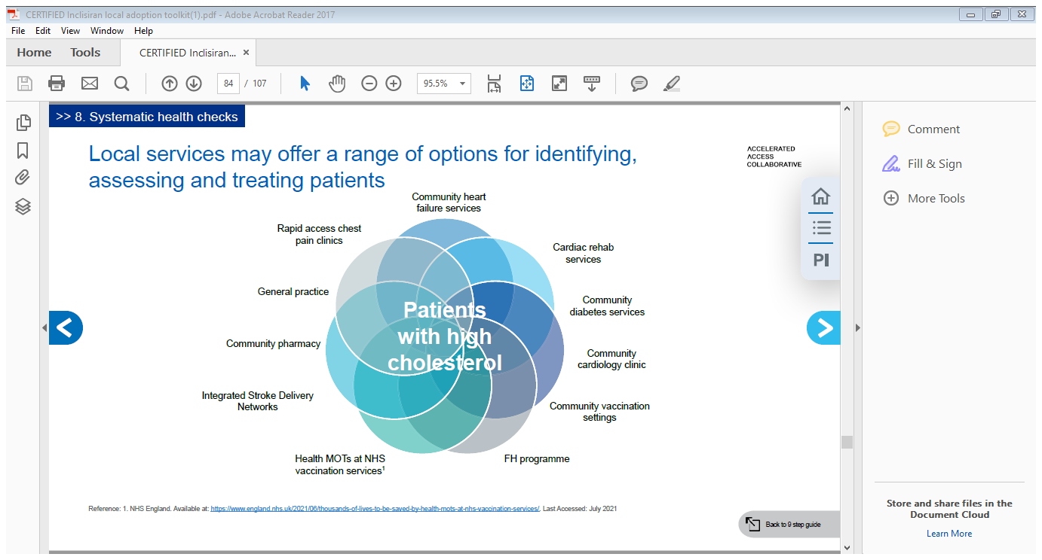
Patient contacted by text/email/letter (if not already at a practice appointment) and asked to book appointment with appropriate healthcare provider

Decide on appropriate treatment for these patients in line with Nice guidance

- Clinician and patient engagement on CVD risk management/cholesterol management
- Improve and support patient adherence to treatment regime and lifestyle changes
- Is Inclisiran suitable?
- Discuss Inclisiran with patient
- Is another Cholesterol check appropriate?
- A decision to administer Inclisiran is taken
- Who is going to administer Inclisiran?
- Is any specific training needed?

Inclisiran ordered - if not stocked by practice
(Process as in Option A)

End
- Patient is provided with basic information about Inclisiran
- Patient provided with patient information sheet or directed to online patient information sheet for Inclisiran.
- Inclisiran is dispensed
- Patient instructed to make next appointment in 3 months’ time
- Practice also creates alert to remind patient to attend

30/11/2021 v2

