Self-Monitoring by people with Diabetes

A Stockport CCG steering group has recently completed a review of self-testing options for people with diabetes. This has been prompted by an increasingly wide use of different strips with no clear rationale or standardisation in the choices made, and some patients having more than one meter adding to confusion and wastage. These factors result in a high level of spend on testing, with a limited impact on patient benefits.

In order to rationalise the usage of self-testing, the CCG developed a scoring tool to determine a formulary choice for diabetes monitoring. After considering applications from manufacturers for strip(s)/meter(s) to be the systems of choice, and analysis of the Greater Manchester Medicines Management Group work, the CCG steering group completed a scoring process and came up with two systems/ strips for blood glucose testing.

It should be noted that the choice of blood glucose test meter is made on formulary recommendations. If a prescriber feels that another blood glucose test strip is more appropriate one to use for an individual patient then they are free to prescribe this, though we would hope for both cost-efficiency and clearer patient care that the formulary choices would be adhered to where possible. Optimise Rx will message these choices. Where an alternative is deemed necessary, the rationale should be recorded in the GP clinical system notes.

Ketone testing may be required for patients with Type 1 diabetes. Where this is required, a dual meter will be provided with a limited number of strips. Clear guidance on the individual circumstances in which to test for ketones will be explained by the healthcare professional managing your care.

We hope that in developing a formulary approach, the CCG will be able to maximise the benefits of self-testing and rationalise prescribing ensuring a cost–effective approach.

Framework for meter selection by clinicians
NOTE: The NHS does not routinely issue a prescription for test strips to those people with type 2 diabetes who are not treated with insulin, unless there is a legitimate reason or benefit for a particular patient (see below).

Blood glucose test meters

Self-monitoring of blood glucose is a beneficial part of diabetes management therefore it is important for people with diabetes to have a blood glucose meter that suits their individual needs. Two meters have been selected and details are presented below. These meters are provided free of charge from GP practices and Specialist services. Clinicians may provide alternative meters as detailed above.

If a person has a new diagnosis of type 2 diabetes or requires a replacement blood glucose meter and has stable diabetes control the following should apply:
  - A CCG approved blood glucose meter with low acquisition cost will be provided;
  - If the CCG approved meter does not suit individual need, an alternative blood glucose meter may be provided and the rationale for choosing the alternative recorded in the GP clinical system notes.

Following a new diagnosis of type 1 diabetes:
  - A CCG approved blood glucose meter/dual testing meter with low acquisition cost will be provided;
  - If the CCG approved meter does not suit individual need, an alternative blood glucose meter may be provided and the rationale for choosing the alternative recorded in the GP clinical system notes.
  - If a dual testing meter is supplied, information on when to test for ketones will be provided.

Blood Glucose Meters Recommended for Patients.
Meter: | GlucoMen Areo | Meter: | Accu-Check Performa Nano | Meter: | Accu-Check Mobile
Manufacturer: | Menarini | Manufacturer: | Roche | Manufacturer: | Roche
Strips:  Cost: | GlucoMen Areo Sensor (50)  £9.95 | Strips:  Cost: | Accu-Check Performa (50)  £9.95 | Strips:  Cost: | Accu-Check Mobile Test Cassette(50)  Cost: £9.99
Lancets:  Cost: | Glucoject lancet plus 33G (200)  £5.50 | Lancets:  Cost: | Fastclix (204)  £5.90 | Lancets:  Cost: | Fastclix (204)  Cost: £5.90
Contact: | Customer Support 0800 243 667 | Contact: | Customer Support 0800 701 000 | Contact: | Customer Support 0800 701 000
Local Contact: | Tracey Gill 07776 227 503 | HCP Support: | 0800 040 7221 | HCP Support: | 0800 040 7221
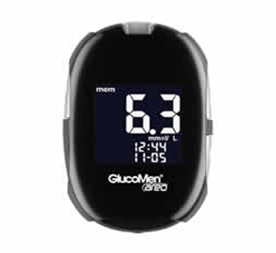 |  | 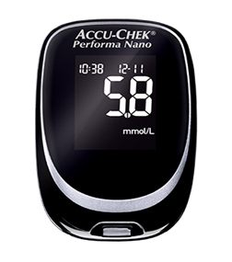 |  | 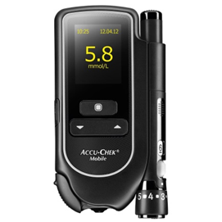

If you have any queries regarding meter selection please contact the Prescribing enquiry line at STOCCG.Pxenquiries@nhs.net

Thanks to Peter Howarth, Tameside and Glossop CCG, Jane O’Brien Diabetes Specialist Midwife, Alison White, Diabetes Specialist Nurse, Heather Procter, GP,
Sister Pat Peach, Practice Nurse and Mike Walker, Prescribing Adviser

Dual Ketone/Glucose Meters Recommended for Patients.

Meter: | GlucoMen Areo 2k | Meter: | GlucoRx HCT ketone meter
Manufacturer: | Menarini | Manufacturer: | GlucoRx
Glucose Strips:  Cost:  Ketone Strips:  Cost: | GlucoMen Areo Sensor (50)  £9.95  GlucoMen Areo β-ketone sensor (10)  £9.95 | Glucose Strips:  Cost:  Ketone Strips:  Cost: | GlucoRx HCT (50)  £9.95  GlucoRx HCT Ketone  £9.95
Lancets:  Cost: | Glucoject lancet plus 33G (200)  £5.50 | Lancets:  Cost: | GlucoRx Lancets  £5.50
Contact: | Customer Support 0800 243 667 | Contact: | Customer Support 0800 007 5892
Local Contact: | Tracey Gill 07776 227 503 | Local Contact: | Justine Phillips 01483 755133
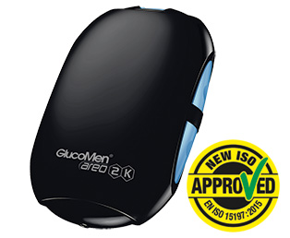 |  | 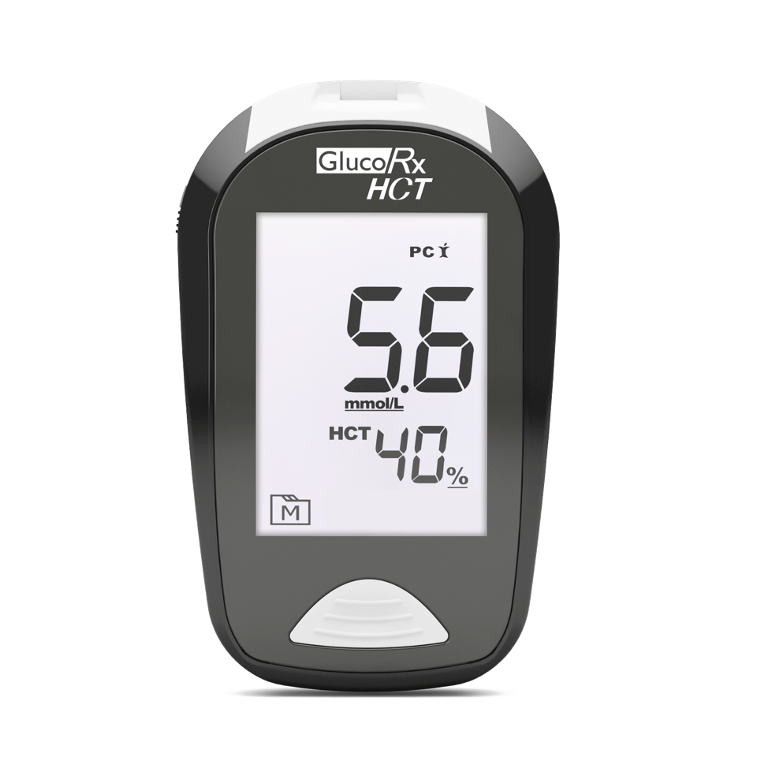

If you have any queries regarding meter selection please contact the Prescribing enquiry line at STOCCG.Pxenquiries@nhs.net

Type 1 diabetes - When should I test my blood glucose levels?
If you have type 1 diabetes you will have insulin prescribed by your GP and you will need to monitor your blood glucose levels as they advise.

This will typically be done:
- Before your insulin dose;
- In-between doses if you are driving a vehicle, or if you or your nurse or doctor feels your blood glucose level is too low (below 4mmols) and needs treating, or medication altering. (Remember, to drive your blood glucose level needs to be above 5mmols and you need to test within 2 hours of getting into the vehicle).
- Always carry your Insulin passport and make sure it is up to date.

For all known patients with diabetes, your GP practice will monitor your overall control by doing an HbA1c blood test every 3-12 months.

Please speak to the person looking after your diabetes if you would like to discuss your home blood testing requirements.

Type 1 diabetes - When should I test for ketones?
Ketone monitoring is an important part of your ‘sick-day rules’, and measuring them will help you self-manage any episode of hyperglycaemia.
Ketones are poisonous chemicals which can build up in the body if your blood glucose levels are consistently elevated, which can sometimes be the case when you are feeling unwell. This can result in a condition called diabetic ketoacidosis (DKA), which if untreated can be a life threatening emergency. The symptoms of DKA include nausea, vomiting, abdominal pain, drowsiness and, in extreme cases, coma. Fruit-smelling breath can also indicate the presence of excess ketones in the body.
This typically means you will need to check your ketone levels if your blood glucose reaches a pre-determined figure (as agreed with your healthcare professional). This would usually be a level greater than 13mmols, alongside concurrent illness. You may be asked to regularly test for ketones when unwell, regardless of your blood glucose level.
You should contact your nurse or GP as a matter of urgency if your ketone reading is high and/or if it continues to rise/fails to reduce despite corrective insulin doses.
Aside from sick day rules, you may also be asked to measure your blood ketones for 2-3 days following a diabetes diagnosis, until your blood glucose levels are stable.
You should not routinely need to measure your ketones if you feel well and your blood glucose is in the agreed range.
As raised ketones can be unexpected, please ensure you have a small supply of in date ketone testing strips at all times. Once used, please obtain more to replace the ones you have used, even if you no longer feel unwell.

Type 2 diabetes - When should I test my blood glucose levels?
The NHS does not usually issue a prescription for test strips to those people with Type 2 diabetes who are not treated with insulin, unless there is a legitimate reason, or benefit for a particular patient.
For all known patients with diabetes, your GP practice will monitor your overall control by doing an HbA1c blood test every 6 - 12 months.

Advice if you use insulin
If you have type 2 diabetes and have insulin prescribed, you should be prepared to monitor your blood glucose levels. This will typically be done:
- Before your insulin dose;
- In-between if you are driving a vehicle, or if you or your nurse or doctor feels your blood glucose level is too low (below 4mmols) and needs treating, or medication altering. (Remember, to drive your blood glucose level needs to be above 5mmols and you need to test within 2 hours of getting into the vehicle).
- If you have a group 2 driving license (for lorries and buses), you need to be able to record and store 3 months’ worth of readings on your meter. For more information, please see the DVLAs ‘Information for drivers with diabetes’ (https://www.gov.uk/government/publications/information-for-drivers-with-diabetes)
- Always carry your Insulin passport and make sure it is up to date.

Advice if you do not use insulin

If you have type 2 diabetes and do not use insulin, self-monitoring of your blood glucose levels is not normally required.
However, you may be asked to test your blood glucose levels at home by your nurse or doctor before meals or before bed as part of an agreed management plan (such as the Diabetes X-PERT Patient Program, or whilst under a specialist team). This may be for an agreed period of time (usually for a week or two) whilst changes are made to your medication. TWO readings a day are usually adequate as long as they are taken at different times each day. For example, before breakfast and evening meal one day, and before lunch and bed the next day and so on for as long as is needed.

Also, if you are on insulin or a group of medications called sulphonylureas (such as gliclazide, glimepiride), or meglitinides (nateglinide and repaglinide) you may need to test before driving or operating machinery. Remember, to drive your blood glucose level needs to be above 5mmols and you need to test within 2 hours of getting into the vehicle.
For more information, please see the DVLAs ‘Information for drivers with diabetes’ (https://www.gov.uk/government/publications/information-for-drivers-with-diabetes)

General advice:

- Only test after meals if asked to do so by your nurse or doctor
- You will also need to monitor for a short time if commenced on steroid medication.
- You should only monitor your blood glucose levels if they are being reviewed regularly by your nurse or doctor and you are using the readings to work towards individual targets set by them. It is not necessary or useful to monitor your blood glucose levels at home unless you are doing so as part of ongoing assessment and evaluation and this will help to make informed decisions about your treatment.
- If you are asked to monitor your blood glucose levels, ensure your nurse or doctor explains the levels you are looking for, and what action to take if they are not achieved.

