**Office 365 – FAQ**

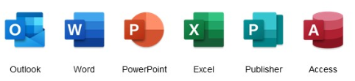

**Q. How long will Office 365 take to download?**

A. This all depends on the speed of your broadband. As a rough guide:

Broadband Speed Download time

20 Mbit /s 25 minutes

60 Mbit /s 8 minutes

200 Mbit /s 3 minutes

Varying factors can affect this such as is your broadband being used at the time. Are you getting the advertised speeds from your ISP or even the age of your laptop.

**Q. How long will this take to install?**

A. This is also dependent on the age of your laptop but any of the recent laptops assigned within the last 12 months, should take about 40 minutes to complete

**Q. Will everything remain the same after installation?**

A. All email signatures should come across, mail archives (.psts) should be also be automatically connected to your mailbox and any shared calendars should be displayed as normal. If this isn’t the case, please open the shared calendars or email archives as you would normally.

**Q. I have upgraded and not all my mail or calendar is showing**

A. As this is new software, an updated ‘profile’ must be created for your mailbox. This can take a while to synchronise depending on the size of your mailbox or calendar. This could be anything from 30 minutes to several hours. Any shared mailboxes or calendars could take longer to sync. If you leave Outlook running, this will populate as a background task while you work.

**Q. I have attempted to apply all updates prior to the installation and nothing is happening**

A. Good news! Your laptop is up to date

**Q. Where are the Microsoft Applications?**

A. Previously, all Office Applications (Word, Excel etc) were stored in the Start Menu under ‘Microsoft Office’

These are now located under each applications name alphabetically on the start menu.

**Q. I have installed Office 365 and I get the following error when signing in with my nhs.net address**

A. All staff should now have Office 365 licences assigned to them. If you receive this error, please contact [simon.beattie@nhs.net](mailto:simon.beattie@nhs.net)* either by email or via Teams

**\*This contact should only be used for licencing errors**

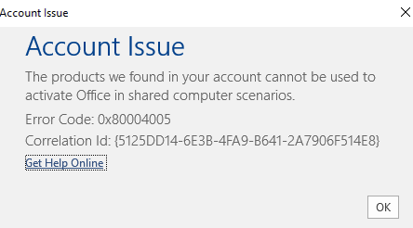**Q. Is support available?**

A. Please contact the GMSS Service Desk on 0161 765 6688 quoting ‘STP project’ or alternatively, email STP at [gmss.stp@nhs.net](mailto:gmss.stp@nhs.net)