**Office 365 – Self Installation**

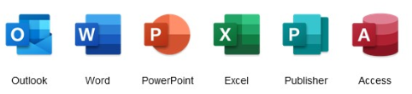

Office 365 will be deployed automatically to your laptop at a future point however in the meantime, we are allowing a flexible method of installation where you will be able to install Office 365 at a time which suits you and fits in with your business requirements.

**Please Note**

* This may be a sizeable download and any users on metered or restricted broadband packages (i.e. a limit on monthly downloads) may find that the allowance may be impacted by this deployment
* GMSS recommend that due to the size of the installation package and possible impact on both the corporate VPN and your home Broadband, that this is installed following ‘sign off’ after your normal working day or overnight

If you have any concerns regarding downloading and performing the upgrade over your own home Broadband service, you can complete the installation from Stopford House.  Access for Stopford House can be requested by completing the Stopford House access application form, available on the CCG intranet by following the link below

<https://www.stockportccg.nhs.uk/staffhub/download/12076/>

**If you are a ‘Power User’ and regularly use Macros within Excel, please email** [**gmss.stp@nhs.net**](mailto:gmss.stp@nhs.net)

**with “Office 365 Macro” in the subject line for advice & guidance before commencing the upgrade**

*Before commencing with the upgrade, please refer the the ‘****FAQ****’ guide which may answer any questions you may have*

Whether Office 365 in installed by yourself or automatically, your laptop must be left powered on for the duration of the installation. Unlike desktop computers, it is not possible to ‘wake up’ the laptops while they are connected over the VPN.

**Please refer to ‘Laptop Power Settings’ guide for instructions on how to amend these settings before installation**

* **Step One – Ensure laptop has applied all updates**

**Before you attempt to install Office 365, please ensure that all mandatory updates have been installed and that your laptop has been rebooted**

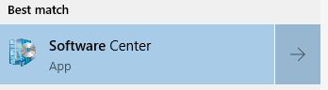Click into the search box on the bottom left and type in ‘software’ and click on ‘software centre’ in the results menu

Click on the result to open Software Centre

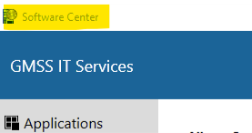Click on *Operating Systems* on left hand Menu and then click on *Apply All Updates*

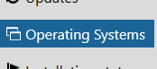 

This will bring up a further dialogue box

please click on Reinstall to continue

If you have any outstanding updates, this may take a while to check and complete. It may also require a reboot.

If no updates are required, this will return you to the dialogue box above. You can then close this and continue.

* **Step Two – Office 365 Installation**

Once this has completed and you have logged back in (if a reboot was required), please follow the previous instructions to return to Software Centre.

You will be presented with all the applications that you are eligible for. One of these will be Office 365. You can either scroll down or search for ‘Office 365’ in the search box in the box at the top right of the page.

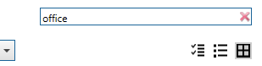

If Office 365 is not showing as an option in Software Centre, please email [gmss.stp@nhs.net](mailto:gmss.stp@nhs.net) with the subject

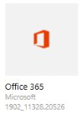‘Software Centre’ in the subject line

If you click on the icon for Office 365, you will be presented with the application details. Please click on to start the setup

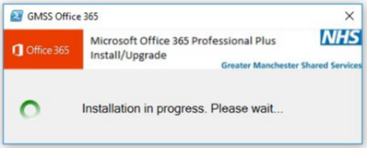

Once installation has started, you should see the following box

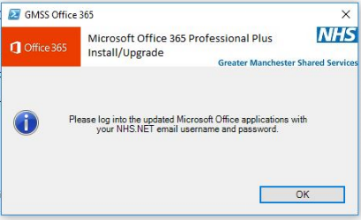

Once installed, you should get confirmation that the installation was successful and asking you to login to Office 365

* **Step Three – Recreate any shortcuts and Activate Office 365**

If you had any existing desktop shortcuts to Outlook, Word, Excel on the desktop or on the Taskbar etc, these will need to be re-created.

Upon opening the new applications, you will first have to authenticate your licence. Instructions on how to complete this are detailed in the ‘**Activation Of Office 365’** document which is attached.

If you encounter any issues during this install, please contact the GMSS Service Desk on 0161 765 6688 or alternatively, email STP at [gmss.stp@nhs.net](mailto:gmss.stp@nhs.net)