

**Office 365 – Laptop Guide (Power Settings)**

Whether Office 365 in installed by yourself or automatically, your laptop must be left powered on for the duration of the installation. Unlike desktop computers, it is not possible to ‘wake up’ the laptops while they are connected over the VPN.

**Prior to your scheduled deployment, you will need to amend the power / sleep settings on your laptop:**

Click on the search bar at the bottom left of your screen and type in ‘power se’ this should bring up the settings dialogue box in the results box at the top of the menu. Once displayed – please click on the results icon to bring up the settings box

 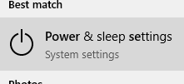 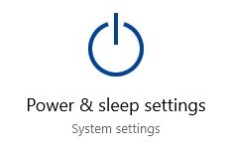

**Please change the default settings for ‘When plugged in’ to*:***

**Screen**



**Sleep**



This can now be closed using the cross on the right hand side.

**On your scheduled date (evening) or if you are installing manually – please ensure that these revised settings are in place, that your laptop remains powered on and connected to your network during the installation.**

Once the deployment is complete, you can amend these changes back to the default of 2 hours for Screen and sleep.

