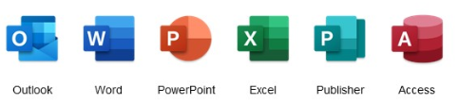


Office 365 – FAQ

Q. How long will this take to download?
A. This all depends on the speed of your broadband. As a rough guide:
Broadband Speed Download time
20 Mbit /s 25 minutes
60 Mbit /s 8 minutes
200 Mbit /s 3 minutes
500 Mbit /s 1 minute
Varying factors can affect this such as is your broadband being used at the time? Are you getting the advertised speeds from your ISP? Age of laptop.
Q. How long will this take to install?
This is also dependent on the age of your laptop but any of the recent laptops, assigned within the last 12 months, should take about 40 minutes to complete
Q. Will everything remain the same after installation?
All email signatures should come across, local archives (.psts) should be automatically connected to your mailbox and any shared calendars should be displayed as normal. If this isn’t the case, please open the shared calendars you have access to as you would normally.
Q. I have upgraded and not all my mail or calendar is showing
As this is new software, an updated ‘profile’ must be created for your mailbox. This can take a while to synchronise depending on the size of your mailbox or calendar. If you leave Outlook running, this will populate as a background task while you work.
Q. I have attempted to apply all updates prior to the installation and nothing is happening
A. Good news! Your laptop is up to date.
Q. Is support available?
A. Of course. Please contact the GMSS Service Desk on 0161 765 6688 or alternatively, email STP at gmss.stp@nhs.net

