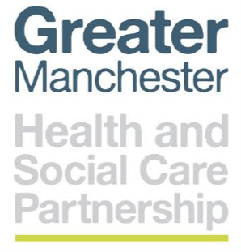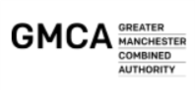

**COVID-19 and Managing deaths in the community**

The management of the majority of deaths in the community has now been taken over by a new service across Greater Manchester.

The new service covers all deaths where a clinician has been involved in their care (which could be remotely) within the 28 days prior to the death and feels death is expected or can be reasonably foreseen. The death could be COVID-19 related, or other causes.

Ideally prepare the service for this in advance of the death:

* Add all relevant information to the patients record: e.g. expected death diagnosis, COVID symptoms or likely COVID illness.

and

* Complete the special patient note proforma and email this to [bardoc.spn@nhs.net](mailto:bardoc.spn@nhs.net)

(This is the statement of intent process now)

Once a practice becomes **aware** of a death – **DO NOT VERIFY THE DEATH YOURSELF (unless prior agreement obtained from BARDOC)**

* To notify the service of the death call the **GM Enabling Safe Certification of Deaths in the Community** (ESCDC) service on **0161 763 8292** or email them on [bardoc.gmdc@nhs.net](mailto:bardoc.gmdc@nhs.net)

* **PLEASE DO NOT USE THIS NUMBER TO ASK QUESTIONS. IF YOU HAVE QUERIES PLEASE EMAIL:** [**england.primarycarecomms@nhs.net**](mailto:england.primarycarecomms@nhs.net)
* If there is a statement of intent /special patient note then email this to [bardoc.spn@nhs.net](mailto:bardoc.spn@nhs.net) if you have not done this already.

Please do not go out and verify the death before calling the service. The verification of death, death certification and any requirement to complete a cremation form with then be the responsibility of the service.

 