MY ADVANCE CARE PLAN

Information Leaflet

Serious illness and growing older bring challenges that many of us would prefer not to think or talk about. It may be difficult to have these conversations and writing this down may seem daunting if no one knows what is important to you including decisions relating to your end of life care.

What is an Advance Care Plan?

Advance care planning gives you an opportunity to discuss and decide what is important to you, particularly in the future as your health needs change. It is a process of discussion between you and those who provide care for you this might be a district nurse, GP, ward staff, social worker, family member or friend. It gives you the opportunity to think, talk and write down things that are important to you when you eventually reach the end of your life.

You may wish to express your thoughts, values, choices, preferences of where you would like to be cared for should there be a time that you are unable to communicate to those involved in your care. It is a key way of keeping your choices central to any decisions that need to be made.

This is a voluntary process and you do not have to complete this if you do not want to.

You should ensure that that your views and wishes are made clear to relatives and carers who may be acting on your behalf, including a person with lasting power of attorney.

Will My choices be met?

There are occasions when circumstances take over and certain actions may not be possible,
having a care plan is useful for our decision making in these circumstances.

What you have written in your plan will always be taken into account and consideration would be sought to help meet those needs.

Can I change My plan?

The plan can be changed at any time in order to meet your needs, it may relate to treatments, medication, or place of choice. Space is provided within the booklet to record any changes that you may wish to make and it is important to inform family friends, carers and professionals involved in your care.

What to do once completed

It is important that your plan is kept safely and readily accessible.

If you go into hospital you should take your plan and share it with other professionals, this way they will know what your choices are.

Is this a Legal Document?

Although this is not a legal document, your wishes and thoughts should be taken into account when a decision is made on a person’s behalf.

Other things you may have considered as part of your plan

- Making a Will or putting your affairs in order.

- Appointing someone to make decisions for you in the future- Lasting Power of Attorney (LPA) this allows you to give another person the right to make decisions should you loose the ability to do so in the future

- Writing an Advance Decision to Refuse Specific Treatments.

Separate leaflets are available, just ask your health care professional for more information.

If you would like this leaflet in a different format, for example, in large print, or on audiotape, or for people with learning disabilities, please contact:
Patient and Customer Services, Poplar Suite, Stepping Hill Hospital. Tel: 0161 419 5678 Information Leaflet. Email: PCS@stockport.nhs.uk.

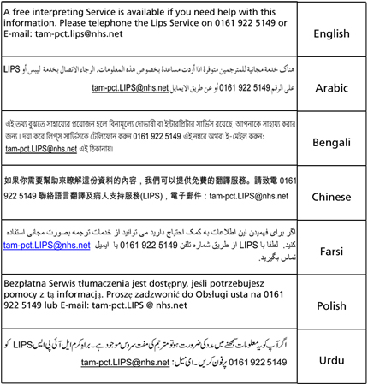

Our smoke free policy
Smoking is not allowed anywhere on our sites. Please read our leaflet 'Policy on Smoke Free NHS Premises' to find out more.

Leaflet number | Intranet Office will supply
Publication date | May 2014
Review date | May 2016
Department | Stockport Specialist Palliative Care Team
Location | Hazel Grove Clinic

