Managed Referral Guidance

Managed referrals enable you to send referrals electronically between primary care and community care organisations. You can use managed referrals for EMIS Web to EMIS Web referrals, from GP practices to extended healthcare providers (EHPs). Managed referrals extend the current paper referral process, which uses letters or faxes for standard referrals.

To use Managed Referrals in EMIS Web, the following conditions must apply:
- To activate Managed Referrals, you must have RBAC activity B0062 Local System Administration in your role profile.
- In order to send Managed Referrals, you will need RBAC activity B8016 Perform Management Restricted Administration in your profile
- Activate Managed Referrals in EMAS Manager.

How to create a Managed Referral
On the Referrals tab of the Care Record, click Add then select Standard Outbound Referral

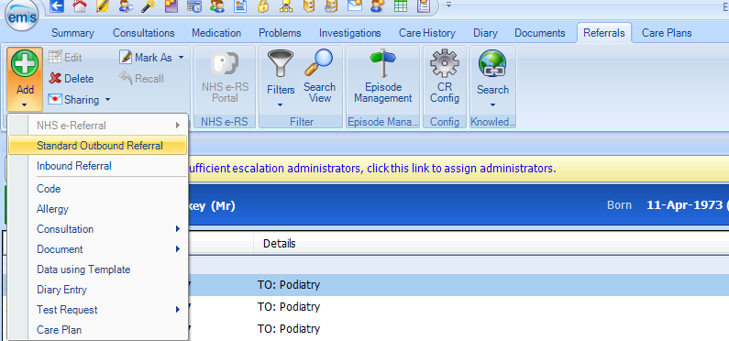
Fill in the Outbound Referral form
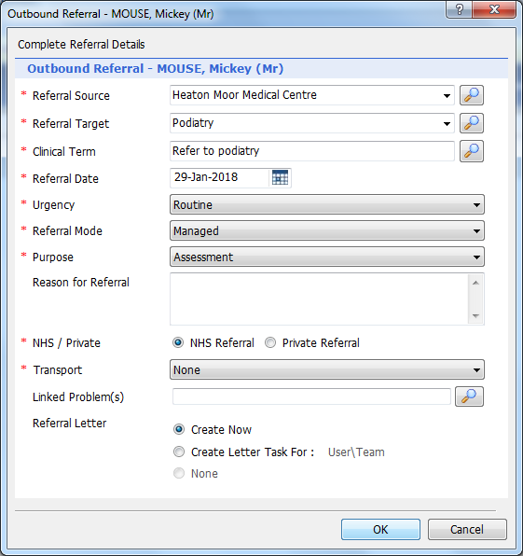 |  | Referral Source Your Surgery Name (for  example Heaton Moor MC)  Referral Target search for SNFT Podiatry  Clinical Term search for 8H7X / Refer to Pod  Urgency select Routine or Urgent  Referral Mode must be Managed  Purpose Assessment  Referral Letter Create Now  Click OK
* If the referral target has not been set up to allow external referrals, it is impossible to select Managed for Referral Mode.

Select the document template - NEW_PODIATRY_REFERRAL_FORM_V6_May_19. Click OK

Select any extra attachments you wish to include with the referral letter
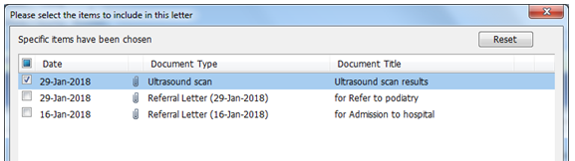

Ensure Reason for referral section on the referral form is completed.
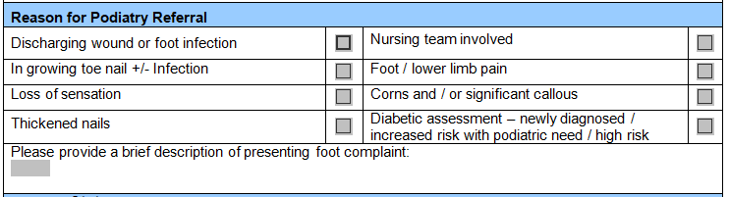

Click File then Save and Send | 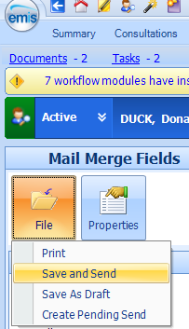
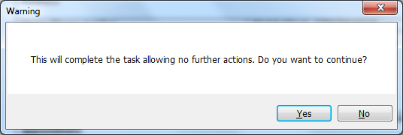
A warning appears – “This will complete the task allowing no further actions. Do you want to continue?” Click Yes
To check the referral - check right-hand side of Referrals tab (you might need to refresh the screen) | 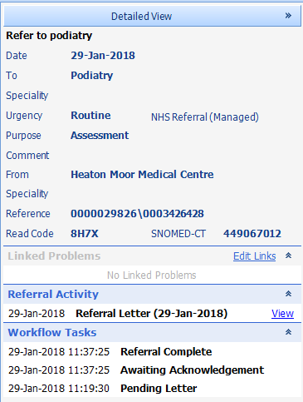
*Top item of Workflow Tasks list should be Referral Complete

How to check the status of the submitted Managed Referral
To enable you to track the progress of managed referrals, you will receive referral notifications in EMIS Web from target organisations, to let you know whether referrals have been accepted, rejected or discharged. These notifications are displayed in the Referrals section of Care Record and in the Referral Management section of Workflow Manager.

Under Workflow Tasks, you can see whether the service has Accepted, Rejected or Discharged your referral.
