Do not attempt cardio-pulmonary resuscitation (DNACPR)

Users often tell us that calls concerning patients in cardiac arrest where there is a DNACPR in place, can be very challenging to manage. Previously, where sudden unexpected deaths have occurred, feedback has been that Category 1 responses for potential cardiac arrest are being generated, with prompts to start BLS (basic life support).

These are considered inappropriate, particularly in the cases of advanced frailty, and do not take into account advanced decisions for end of life care plans. Cases have been reported where the ‘expected death’ or ‘discovery of a corpse’ routes have been selected to avoid generating a category 1 response and BLS instructions presenting.

A solution has been agreed and ratified for use by the NCGG (National Clinical Governance Group).

The changes will apply to sudden, unexpected deaths in adults only, and where they are in a care home. The Care Quality Commission (CQC) who are the regulators of care homes in England have produced clear guidance on this issue.

The requirement is to communicate clear and accurate information about residents in care homes, and it is part of their inspection criteria that staff are in trained in the appropriate management of end of life care and wishes.

These changes have been made within ‘early exit’ where sudden, unexpected death
has been selected. You will be presented with new questions as shown below:

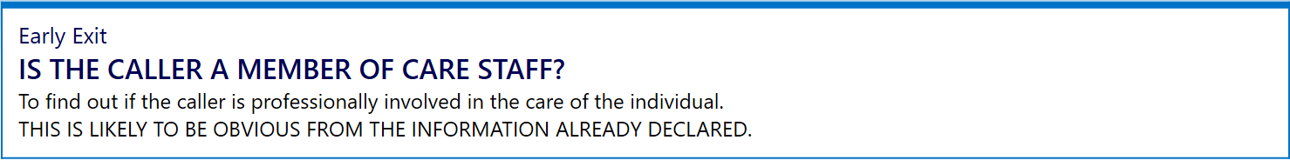

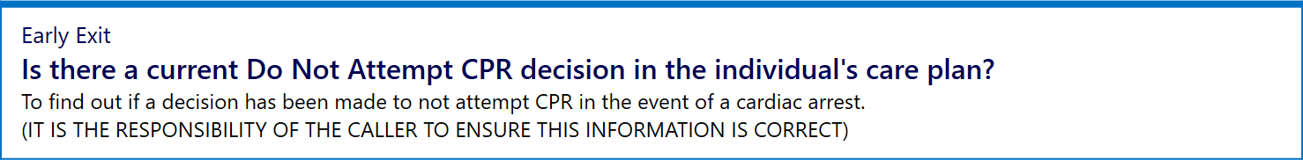

These additional questions will provide for a person responsible for the care of the patient (registered nurse, manager or care staff in a care home) to confirm that a DNACPR or ReSPECT (Recommended Summary Plan for Emergency Care and Treatment) order is held, is current, signed and with the caller at the time of the call if a sudden, unexpected death occurs.

If any of these criteria are not met i.e. not sure or no is answered to any of the above questions, an ambulance will be dispatched and prompts for BLS will be presented.

Additional safety measures have also been put in place to account for situations where the likely cause of the sudden, unexpected death is not anticipated on the DNACPR e.g. choking on food, allergic reaction, violence or injury.

If answering positively to any of these questions an ambulance will be dispatched and prompts for BLS will be presented.

ReSPECT (Recommended Summary Plan for Emergency Care and Treatment)

What is ReSPECT?
The ReSPECT process creates a summary of personalised recommendations for a person’s clinical care in a future emergency in which they do not have capacity to make or express choices. Such emergencies may include death or cardiac arrest, but are not limited to those events.

The process is intended to respect both patient preferences and clinical judgement. The agreed realistic clinical recommendations that are recorded include a recommendation on whether or not CPR should be attempted if the person’s heart and breathing stop.

It provides health and care professionals responding to that emergency with a summary of recommendations to help them make immediate decisions about that person’s care and treatment.

The plan is created through conversations between a person and their health professionals. It’s recorded on a form and includes their personal priorities for care and agreed clinical recommendations about care and treatment that could help to achieve their wishes.

ReSPECT can be for anyone but will have increasing relevance for people who have complex health needs, people who are likely to be nearing the end of their lives, and people who are at risk of sudden deterioration or cardiac arrest.

The key elements of ReSPECT are:

- Recommended – these are recommendations not ‘orders’ or legally-binding decisions;
- Summary – this does not replace more detailed treatment plans or advance care plans but is a summary for immediate access in a crisis;
- Emergency – this summary relates only to care and treatment in a crisis; other plans may include aspects of non-urgent care and treatment.

How does it work in practice?
The plan should stay with the person and be available immediately to professionals faced with making emergency decisions where the patient has lost capacity to participate in making those decisions.

ReSPECT may be used across a range of health and care settings, including the person’s own home, an ambulance, a care home, a hospice or a hospital

How would I know if there is a ReSPECT plan in place?
A caller may declare to you that the patient they are calling about has a ReSPECT plan in place. The change to the questions in R17 through the ‘Early Exit’ – sudden, unexpected death route will also prompt you to ask if there is a DNACPR plan in place, and the supporting information also states that it could be referred to as a DNACPR, DNAR or ReSPECT decision document.

It also states that the document must be the original copy, current, signed and dated by a doctor. www.respectprocess.org.uk

