Antibiotic Search Instructions
To complete this audit there are three steps
- Step one to run the search
- Step two manipulate the data in excel to select the audit sample
- A doctor to review the sample and rag rate the prescriptions issued.

Step one
- Click Antibacterial Drugs issued previous month Auto Report
- Choose Run at the top of the screen  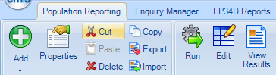 |  |  | - Click Yes  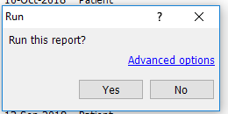
- Once the report has run Choose View Results |  | - This will display the report  Click on Export at the top of the screen  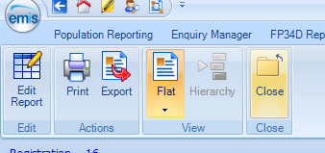
- To display another screen  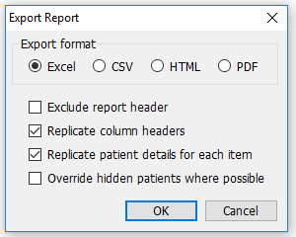 | - Tick Replicate column headers  - Tick Replicate patient details for each item  - Choose OK and save the file where you saved the excel spreadsheet

Step two
Leave EMIS
Go to your Desktop
- Open Antibacterial Drugs issued previous month Auto Report
- Highlight columns A to D and click copy
- Open Master Antibiotics usage previous month
- Highlight columns A to D and click paste
- Press Copy 5% of data to Sheet 2
- Press Delete this data

Step three
Go to Sheet 2 and RAG rate and complete and learning points

