**Digital Learning Solutions – Registration Guide**

Digital Learning Solutions provides access to training and assessment products covering the full range of competencies for users of the main Microsoft Office products, from basic through to advanced. It has been developed to provide an officially recognised route of learning and certification for the whole workforce. Packages covered include; Microsoft Word, Excel, Outlook, PowerPoint, LinkedIn and Twitter. There are also resources to help with fundamentatl digital skills such as mouse and keyboard skills.

Its purpose is to encourage everyone working with IT to review their current IT skills and knowledge against recognised standards, determine what their skill gaps are and then identify their current and future training requirements based on the products that are available.

NHS GM (Stockport) has been set up as a Centre so all staff Stockport Primary Care can access these resources free of charge.

All users will re required to register for the system.

1. Click on this link – [**Digital Learning Solutions**](https://www.dls.nhs.uk/Home)
2. The following page will be displayed:

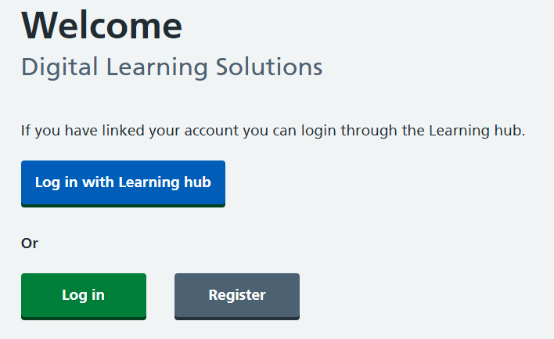

1. Choose ‘Log in’ (if you have previously used DLS). Otherwise please choose ‘Register’.
   1. **Option 1 - Log in**: Use your DLS details.

You should then be able to click on ‘learning portal’. Click on ‘available activities’ to see all the courses on offer and enrol or if you have already started a course it will show under ‘current activities’

* 1. **Option 2 - Register**: Choose ‘NHS GM (Stockport)’ from the drop down list and enter your details for registration.   
       
     You will be sent an email to verify your email address and we will also be asked to verify your registration as part of the centre. Once both of these steps have been completed you will be able to log in. When you have been verified you will receive an email advising your registration has been approved by the centre administrator.

Please use your email address to login. You should then be able to click on ‘learning portal’. Click on ‘available activities’ to see all the courses on offer and enrol or if you have already started a course it will show under ‘current activities’

Please note you may receive an error message advising your email cannot be verified – this will be if we have not yet been able to verify your account from within the centre platform. When you have been verified you will receive an email advising your registration has been approved by the centre administrator.

When you next go to login you may receive this message:

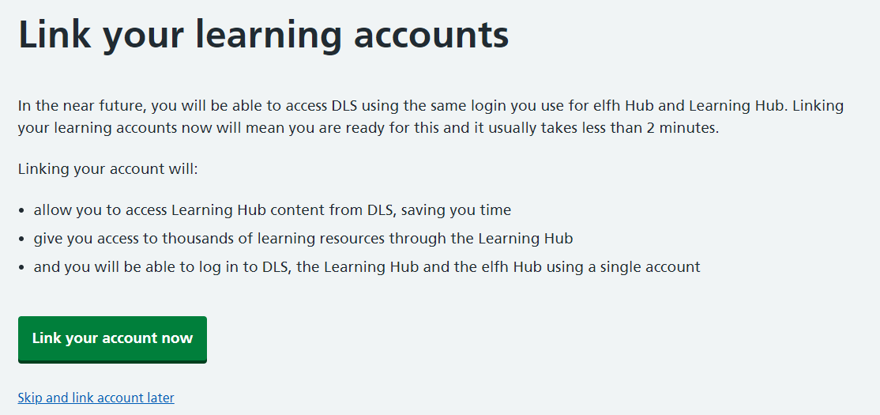

You can choose to link and add your e-lfh details or choose the skip and link account later option.