**Stockport bruising / injury to a child pathway**

START

Yes

Consider IM antibiotics

Admit via 999 ambulance

Liaise with paeds on call

Is the child seriously unwell ?sepsis

Are ALL marks in keeping with sepsis?

No

Yes

Discussion with parents:

* There are some marks on the skin that we don’t know the cause of.
* In some cases bruising can be caused by medical conditions, whilst in others it can be as a result of an injury.
* We cannot determine if there may be a medical reason for these and therefore we need the paediatricians to assess
* Because sometimes bruising can be caused by injury, the policy in Stockport is that we need to refer to the MASSH, who will then arrange the paediatric assessment

No

Is there a reasonable explanation of mechanism of injury?

**NB: Have a higher index of suspicion / lower threshold to refer**

No

Yes

Is there a reasonable explanation of mechanism of injury

Discuss need to refer to MASSH in line with local policy with parents

Is the child mobile / cruising?

Yes

Complete online Level 4 proforma [www.stockport.gov.uk/contacting-the-massh](http://www.stockport.gov.uk/contacting-the-massh) & also call MASSH on 0161 217 6028 (0161 718 2118 OOH)

No

No

No

Yes

Yes

MASSH / CSC will:

Liaise with paeds to book S47 medical assessment

Liaise with parents regarding attendance at hospital

Arrange strategy / professionals meeting

Document findings / outcomes / plan

Make diagnosis

Could the mark represent a bruise / injury?

See next page

Consider discussion with SG lead / colleagues

Document findings / outcomes / plan

Accidental bruising in babies

RARE - Accidental bruising is rare in pre-mobile infants (0.1-1.3% prevalence)

COMMONLY ISOLATED – 81.7% of accidental injuries result in no more than 1 bruise

LOCATION – Commonly over bony prominences (73%) – forehead, chin, shins, knees, elbows & usually (78%) anterior. Very unusual to get bruising both front AND back

SIZE – Typically small, < 15mm diameter

DEVELOPMENT – More common as a child becomes more mobile

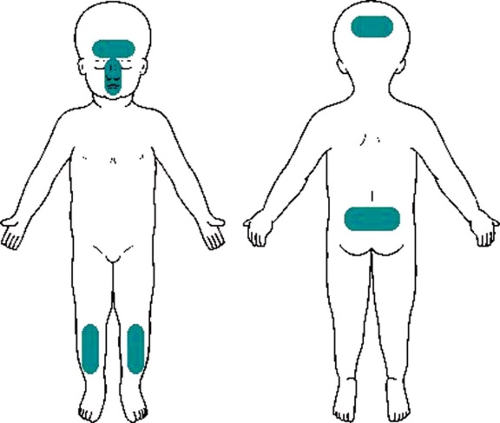 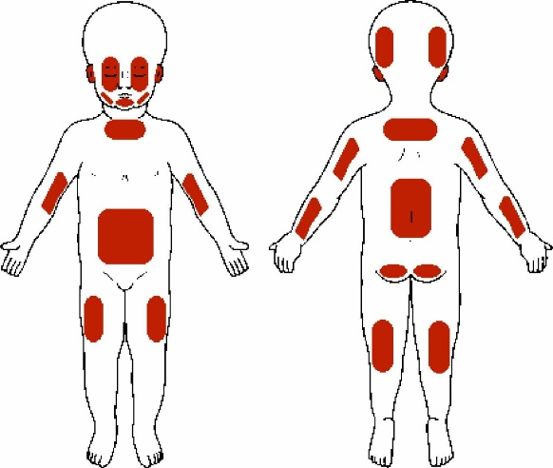

Typical sites of ACCIDENTAL injuries Typical sites of INFLICTED injuries

**Red flags:**

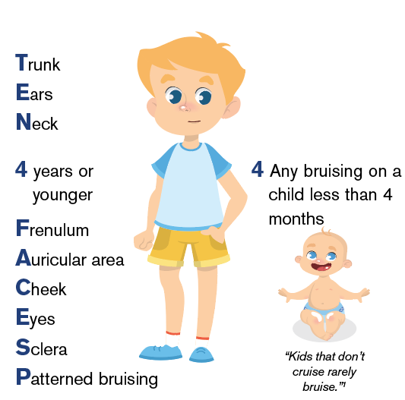

Not independently mobile

Posterior surface (or both front & back)

Multiple bruises from a single incident

Petechiae

Bruising away from bony prominences

Bruising to ears, neck, genitals

Specific patterns (e.g. linear / tramline / slap marks / pinch / fingertip / bite)

Bruising of uniform shape

Clustering of bruising

Can the child go home pending CSC collection?