**Combatting racial discrimination against minority ethnic nurses, midwives and nursing associates: Resource for nursing and midwifery professionals registered with the Nursing and Midwifery Council.**

**Communications pack**

Today NHS England has published, in partnership with the Nursing and Midwifery Council and NHS Confederation, a resource for nursing and midwifery professionals registered with the Nursing and Midwifery Council working in the NHS on combatting racial discrimination against minority ethnic nurses, midwives and nursing associates.

This is available on NHS England’s website - <https://www.england.nhs.uk/publication/combatting-racial-discrimination-against-minority-ethnic-nurses-midwives-and-nursing-associates/>

This pack contains content for regional teams, ICBs and provider organisations for use on your social channels, bulletins, newsletters, staff intranet or websites. Please feel free to personalise it for your audience. It includes:

* Key messages
* Micro bulletin text
* Short bulletin text
* Example tweets and Twitter card.

**Key Messages**

* Racism is unacceptable and it has no place in health and care. But we know that it exists and that the impact on people can be devastating. Our NHS staff survey and Workforce Race Equality Standard data tells us that we need to do more to combat discrimination and racism.
* NHS staff are our greatest asset, and this resource helps to ensure that we retain and support nursing and midwifery professionals who are our largest staffing group.
* As registered professionals, nurses, midwives and nursing associates all have responsibility under the NMC Code to challenge discriminatory behaviour, creating an environment where people are treated as individuals and with dignity and respect.
* The resource is for all nursing and midwifery professionals registered with the Nursing and Midwifery Council working in the NHS, and supports all nurses, midwives and nursing associates across health and care to combat racism and secure their own and their colleagues’ wellbeing and psychological safety.
* The resource can help nurses, midwives and nursing associates to act according to best professional practice when experiencing racism, witnessing racism and leading anti-racism. It includes practical examples and tools to help discuss, explore and challenge racism safely and effectively.
* Provided within the resource is the nursing and midwifery anti-racism resource framework, informed by the insights of experienced nurses, midwives and NHS leaders, and a rapid qualitative evidence review.
* The resource utilises the framework and reflects four domains of the NMC Code for professional standards of practice and behaviour for nurses, midwives and nursing associates: prioritise people; practise effectively; preserve safety; and promote professionalism and trust.
* All NHS organisations should promote anti-racist policy, practice and procedures, and know how to respond to racist practices, behaviours and incidents.
* The resource outlines the expected behaviours from NHS organisations and leaders, which includes the provision of training to support zero tolerance policies; senior leaders acting as proactive allies by taking the appropriate action; the provision of safe spaces for conversations such as robust staff networks and events; and organisations working with staff to educate and reform practice.
* NHS leaders and boards prioritise staff safety and the NHS has in place a range of well-being support offers. This resource further supports the wellbeing of staff and aims to protect psychological safety.
* This resource does not replace existing policies and procedures for speaking up and managing racism. It is a resource to support best practice in line with organisational policies and procedures.
* [Combatting racial discrimination against minority ethnic nurses, midwives and nursing associates.](https://www.england.nhs.uk/publication/combatting-racial-discrimination-against-minority-ethnic-nurses-midwives-and-nursing-associates/) Resource for nursing and midwifery professionals registered with the Nursing and Midwifery Council is now published and also available for download.

**Micro bulletin text (word count <50)**

**Combatting racial discrimination against minority ethnic nurses, midwives and nursing associates**

NHS England, in partnership with the Nursing and Midwifery Council and NHS Confederation have published a resource to support all registered nursing and midwifery professionals working in the NHS and across all health and care settings, to combat racial discrimination against minority ethnic nurses, midwives and nursing associates. <https://www.england.nhs.uk/publication/combatting-racial-discrimination-against-minority-ethnic-nurses-midwives-and-nursing-associates/>

**Short bulletin text (word count <100)**

**Combatting racial discrimination against minority ethnic nurses, midwives and nursing associates.**

Racism is unacceptable and it has no place in health and care. But we know that it exists and that the impact on people can be devastating.

NHS England, in partnership with the Nursing and Midwifery Council and NHS Confederation have published a resource to support registered nursing and midwifery professionals working in the NHS and across health and care to combat racial discrimination against minority ethnic nurses, midwives and nursing associates.

[The resource](https://www.england.nhs.uk/publication/combatting-racial-discrimination-against-minority-ethnic-nurses-midwives-and-nursing-associates/) provides practical tools to help nurses, midwives and nursing associates to discuss, explore and challenge racism safely and effectively, and to act according to best professional practice when experiencing racism, witnessing racism and leading anti-racism.

**Example tweets and Twitter card**

**Tweet 1**

This new resource published by @NHSEngland, @NMCNews and @NHSConfed provides practical tools to help all registered nursing and midwifery colleagues working within the NHS to discuss, explore and challenge racism safely and effectively. #teamCNO <https://www.england.nhs.uk/publication/combatting-racial-discrimination-against-minority-ethnic-nurses-midwives-and-nursing-associates/>

**Tweet 2**

Our staff are our greatest asset and this new resource helps to ensure we retain and support them by helping nursing and midwifery professionals combat racism and secure their own and their colleagues’ wellbeing and psychological safety. <https://www.england.nhs.uk/publication/combatting-racial-discrimination-against-minority-ethnic-nurses-midwives-and-nursing-associates/> #teamCNO

**Social media graphic**

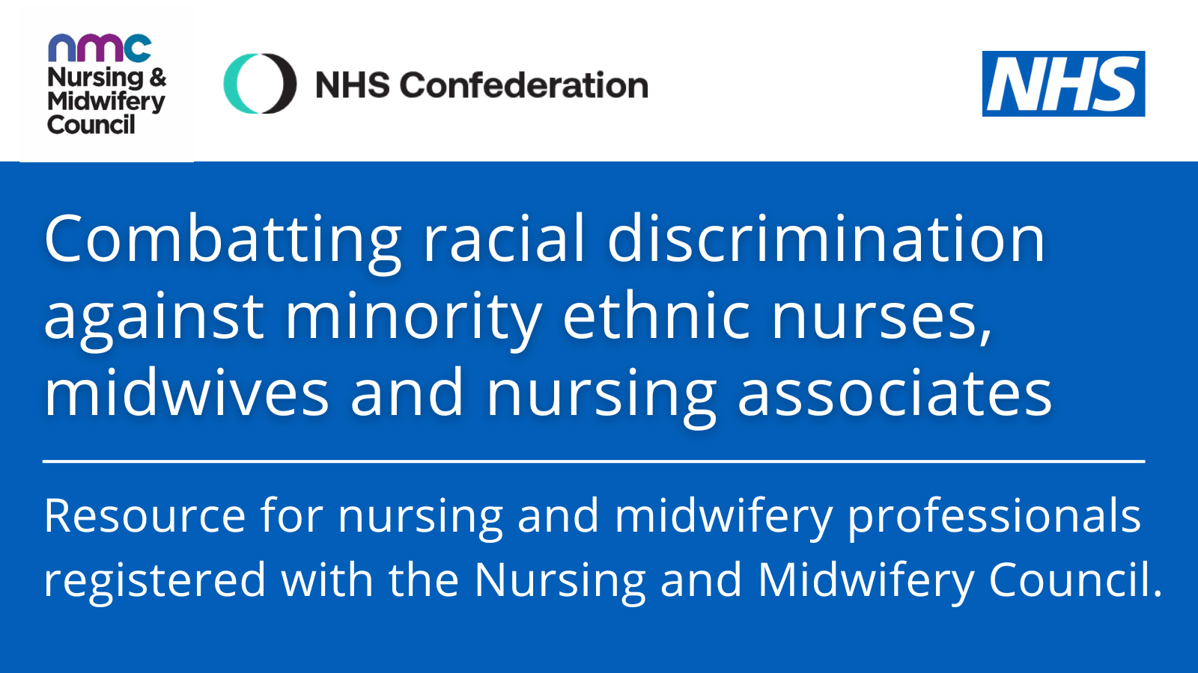

Alt text: Combatting racial discrimination against minority ethnic nurses, midwives and nursing associates. Resource for nursing and midwifery professionals registered with the Nursing and Midwifery Council.