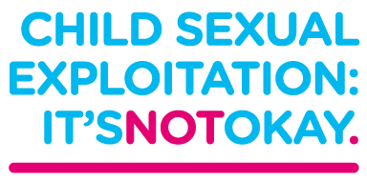
Parents and Carers
Have you heard about
Child Sexual Exploitation?
Don’t switch off….when they’re switched on!
Keep switched on….when they’re off out
Want some more information?
As part of Greater Manchester Project Phoenix, the Stockport CSE Team will be holding a stall, handing out information and talking to members of the public at:


Cale Green Park “Summer in the Park”

On
Saturday 23rd June
1pm-4.30pm

https://sites.google.com/view/friendsofcalegreenpark

