Seven day service

# Introduction

There is an agreement across GM for all areas to have access to a seven day service. The Healthier Together project in Greater Manchester gave a pledge that there would be a weekend offer in all areas by the end of 2016. Stockport met this challenge but the current service is not well used and not good value for money.

# Current situation

There are currently two services running to deliver seven day services.

The first is at Mastercall and was set up to meet the immediate challenge at the end of 2016. There is no contract in place and it is unclear if the implied contract would be directly with Mastercall or through Viaduct as was the intention at the time.

The second was a two month pilot established in the Heatons Neighbourhood to test the EMIS access to notes and access to pathology to support such a service. This commenced on the 1st May and is due to close on 30th June.

The 17/18 budget for the 7 day services is £1.8m.

Commitment to date

Mastercall Service           £180k

Heaton Moor Pilot           £ 25k

**Total                                   £205k**

## Heaton’s Pilot

Early evaluation of the Heaton’s pilot shows that all three practices are using and like this service. In the first four weekends that the service was running 216 patients were seen. 95% plus of the available GP appointments were booked. The first few weeks of the pilot there was a low uptake of nurse appointments however this has improved in recent weeks. The uptake is now similar to that of the GP appointments. HCA appointment uptake remains relatively low. Average DNA rate for all appointments is around 15%. In general there is an equal split between the days on which these occur. There were some initial problems with the blood collection service with all results being returned to Heaton Moor MC as the host practice. These have now been sorted out and results go to the patient own GP practice. Having access to full patient records via EMIS RC has worked well.

Patients who used the service had been asked for their feedback. Most patients had found out about the service from their own practices receptionist/s. The majority of the patients said that they had had difficulties getting to see a clinician at their own practice on a weekday. All patients said they would recommend the service and use it again. One of the main reasons cited for using the service was that the patients worked from Monday to Friday.

There have been challenges and Heaton Moor MC has reviewed the system on Mondays after the service to evaluate and adapt procedures to make them work for all three practices involved.

## Mastercall Service

Latest activity from Mastercall (See graph) shows very variable use of the service with approximately 80 appointments in May 2017. At a cost of £90K this is not good value for money making an appointment cost about £1125.

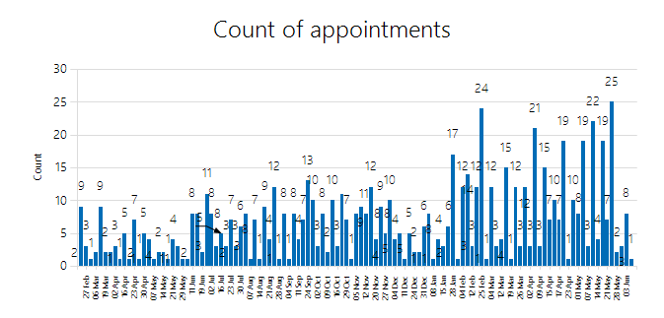

In comparison over the same time period 216 patients were seen in the Heatons pilot. The service was used by all the participating practices. This makes the cost in the pilot around £58 per appointment.

# Future plan

Given the allocation of £1.8m from GM to support the seven day service and the current Mastercall activity being at about £90k a month we are not offering the scale of service anticipated by the centre. This will be addressed through the response to the business case that is currently with Viaduct for development and should come into place during September 2017.

The local requirements for the 7 day services being developed by Viaduct are:

* Capacity for practices/the central booking team to book patients identified through the find and treat services, providing appointments to screen for risk factors and provide advice on their management, and to optimize treatment where possible.
* Capacity for practices/the central booking team to book patients who require vaccination & immunization (excluding travel vaccinations except for those allowable through GMS)
* Capacity for practices/the central booking office to book patients with a long term condition for prevention and management of long term conditions. These appointments should be available for those people who are working and those people for whom there is an advantage if a working carer is able to accompany them or they themselves are a carer and able to get support at the weekend. It is anticipated that the additional appointments will enable the movement of work around the week and allow for longer appointments when required for some people with more complex needs.
* An ability for patients to book routine appointments at the weekends/evenings
* An ability for a small number of urgent on the day appointments at the weekends evenings
* Where possible the provision of multi-disciplinary services that offer a one stop approach are encouraged and the provider should consider how services can be organized to facilitate this.
* See any patients that a practice identified on Friday who in order to keep them at home they would want to be reviewed medically over the weekend.
* Offer triage, visits, appointments and support to the neighbourhood team will be available from 8 am to 8 pm every day

# Proposal

There is a new service in planning that will commence in the next three months. The value for money of the service in the Heatons although serving a much smaller area is significantly better than that for the service at Mastercall. It is proposed that the Heatons service is continued during the development of the new service. An extension to the contract is proposed to take it to the end of September 2017.

The Mastercall service should be decommissioned as soon as the new service is ready to commence. Given this is due to be in three months, notice should be given very soon.

Roger Robets June 2017